UNITED STATES
SECURITIES AND EXCHANGE COMMISSION
Washington, D.C. 20549
______________________
FORM 8-K
______________________
CURRENT REPORT
PURSUANT TO SECTION 13 OR 15(d)
OF THE SECURITIES EXCHANGE ACT OF 1934
Date of Report (date of earliest event reported): October 20, 2026
______________________
CASS INFORMATION SYSTEMS, INC.
(Exact name of registrant as specified in its charter)
______________________
Missouri |  |  | 000-20827 |  |  | 43-1265338
(State or other jurisdiction of  incorporation or organization) |  |  | (Commission  File Number) |  |  | (I.R.S. Employer  Identification No.)
12444 Powerscourt Drive, Suite 550  St. Louis, Missouri |  |  | 63131
(Address of principal executive offices) |  |  | (Zip Code)
(314) 506-5500
(Registrant’s telephone number, including area code)
______________________
Check the appropriate box below if the Form 8-K filing is intended to simultaneously satisfy the filing obligation of the registrant under any of the following provisions:
☐ |  |  | Written communications pursuant to Rule 425 under the Securities Act.
☐ |  |  | Soliciting material pursuant to Rule 14a-12 under the Exchange Act.
☐ |  |  | Pre-commencement communications pursuant to Rule 14d-2(b) under the Exchange Act.
☐ |  |  | Pre-commencement communications pursuant to Rule 13e-4(c) under the Exchange Act.
Securities registered pursuant to Section 12(b) of the Act:
Title of each class |  |  |  |  |  | Trading  Symbol |  |  |  |  |  | Name of each exchange  on which registered
Common Stock, par value $0.50 per share |  |  |  |  |  | CASS |  |  |  |  |  | Nasdaq Global Select Market
Indicate by check mark whether the registrant is an emerging growth company as defined in Rule 405 of the Securities Act of 1933 (§230.405 of this chapter) or Rule 12b-2 of the Securities Exchange Act of 1934 (§240.12b-2 of this chapter).
Emerging growth company ☐
If an emerging growth company, indicate by check mark if the registrant has elected not to use the extended transition period for complying with any new or revised financial accounting standards provided pursuant to Section 13(a) of the Exchange Act. ☐

Item 2.02. Results of Operations and Financial Condition.
On October 22, 2026, Cass Information Systems, Inc. (the “Company”) issued a press release announcing its financial results for the third quarter of fiscal 2026. A copy of this press release is attached hereto as Exhibit 99.1 and incorporated herein by reference.

Also on October 22, 2026, the Company made available on the Investors section of the Company’s website at www.cassinfo.com, an earnings supplement that includes information about the Company’s business and developments and certain financial information relating to the third quarter of fiscal 2026. The information contained in this presentation is summary information that is intended to be considered in the context of the Company’s Securities and Exchange Commission filings and other public announcements that the Company may make, by press release or otherwise, from time to time. A copy of the earnings supplement is attached hereto as Exhibit 99.2 and incorporated herein by reference.

The Company has used, and intends to continue using, the Investors portion of its website to disclose material non-public information and to comply with its disclosure obligations under Regulation FD. Accordingly, investors are encouraged to monitor the Company’s website in addition to following press releases, SEC filings, and public conference calls and webcasts.

The information reported under this Item 2.02 of Form 8-K, including Exhibit 99.1 and Exhibit 99.2 is being furnished and shall not be deemed to be “filed” for the purposes of Section 18 of the Securities Exchange Act of 1934, as amended (the “Exchange Act”), or otherwise subject to the liabilities of such section, nor shall such information be deemed incorporated by reference in any filing under the Securities Act of 1933, as amended, or the Exchange Act, except as shall be expressly set forth by specific reference in such filing.

Item 8.01. Other Events.
On October 20, 2026, the Company’s Board of Directors declared a fourth quarter dividend of $0.34 per share payable on December 14, 2026 to shareholders of record on December 4, 2026.

Item 9.01. Financial Statements and Exhibits.
(d) Exhibits.
Exhibit Number |  |  |  |  |  | Description
99.1 |  |  |  |  |  | Press release issued by Cass Information Systems, Inc. dated October 22, 2026.
99.2 |  |  |  |  |  | Earnings supplement made available on the Investors section of the Company’s website.
104 |  |  |  |  |  | Cover Page Interactive Data File (embedded within the Inline XBRL document).

1

SIGNATURES
Pursuant to the requirements of the Securities Exchange Act of 1934, the registrant has duly caused this report to be signed on its behalf by the undersigned hereunto duly authorized.
Dated: October 22, 2026
 |  |  | CASS INFORMATION SYSTEMS, INC.
 |  |  | By: |  |  | /s/ Martin H. Resch
 |  |  | Name: |  |  | Martin H. Resch
 |  |  | Title: |  |  | President and Chief Executive Officer
 |  |  | By: |  |  | /s/ Michael J. Normile
 |  |  | Name: |  |  | Michael J. Normile
 |  |  | Title: |  |  | Executive Vice President and Chief Financial Officer

2

Exhibit 99.1

Contact: Cass Investor Relations
ir@cassinfo.com
October 22, 2026
Cass Information Systems reports Third Quarter 2026 Results
ST. LOUIS – Cass Information Systems, Inc. (Nasdaq: CASS) (the Company or Cass) today reported its third quarter 2026 earnings.

Strong year-over-year growth in net income and EPS

Continued net interest margin expansion

Third Quarter Financial Highlights
(All comparisons refer to the third quarter of 2025, except as noted)

•Net income and diluted earnings per share of $10.6 million and $0.81, respectively, increases of 16.1% and 19.1%, respectively.
•Return on average equity of 17.46%.
•Increase in net interest margin to 4.02% compared to 3.87%.
•Increase in net interest income of $1.9 million, or 8.9%.
•Increase in financial fees of $1.2 million, or 11.8%.
•Increase in total revenues of $2.6 million, or 5.3%.
•Increase in transportation dollar volumes of 14.5%.
•Increase in average deposits of $79.2 million, or 7.8%.
•Increased quarterly dividend by $0.02 to $0.34 per share for the fourth quarter of 2026.

Martin Resch, the Company’s President and Chief Executive Officer, noted, “We are pleased with our third quarter financial results, reflecting continued profitability growth throughout all of our lines of business.” Resch added, “Recent CassPay and Facilities client wins, combined with higher transportation and facility dollar volumes, present us with an enviable outlook for continued growth in assets, net interest income and financial fees in coming quarters. The improved revenue outlook, when combined with additional technology enhancements designed to improve client experience and reinforce our competitive advantages, should allow for enhanced profitability for the next several quarters.”

Earnings for the third quarter of 2026 are summarized as follows:

($ in thousands, except per share data) |  |  | Three Months Ended |  |  |  |  |  |  |  |  |  |  |  |  |  |  |  |  |  |  |  |  |  |  |  |  |  |  |  |  |  | Nine Months Ended
 |  |  | 9/30/26 |  |  |  |  |  | 6/30/26 |  |  |  |  |  | 3/31/26 |  |  |  |  |  | 12/31/25 |  |  |  |  |  | 9/30/25 |  |  |  |  |  | 9/30/26 |  |  |  |  |  | 9/30/25
Net income from continuing operations |  |  | $ | 10,568 |  |  |  |  | $ | 10,575 |  |  |  |  | $ | 8,739 |  |  |  |  | $ | 8,189 |  |  |  |  | $ | 9,212 |  |  |  |  | $ | 29,882 |  |  |  |  | $ | 22,922
Net income |  |  | $ | 10,574 |  |  |  |  | $ | 10,587 |  |  |  |  | $ | 8,832 |  |  |  |  | $ | 8,189 |  |  |  |  | $ | 9,106 |  |  |  |  | $ | 29,993 |  |  |  |  | $ | 26,927
Diluted earnings per share from continuing operations |  |  | $ | 0.81 |  |  |  |  | $ | 0.81 |  |  |  |  | $ | 0.66 |  |  |  |  | $ | 0.62 |  |  |  |  | $ | 0.69 |  |  |  |  | $ | 2.28 |  |  |  |  | $ | 1.69
Diluted earnings per share |  |  | $ | 0.81 |  |  |  |  | $ | 0.81 |  |  |  |  | $ | 0.67 |  |  |  |  | $ | 0.62 |  |  |  |  | $ | 0.68 |  |  |  |  | $ | 2.29 |  |  |  |  | $ | 1.99
Return on average equity |  |  | 17.46% |  |  |  |  |  | 17.72% |  |  |  |  |  | 14.63% |  |  |  |  |  | 13.45% |  |  |  |  |  | 15.29% |  |  |  |  |  | 16.60% |  |  |  |  |  | 15.51%
Return on average assets |  |  | 1.60% |  |  |  |  |  | 1.67% |  |  |  |  |  | 1.42% |  |  |  |  |  | 1.28% |  |  |  |  |  | 1.44% |  |  |  |  |  | 1.56% |  |  |  |  |  | 1.48%
Net interest margin |  |  | 4.02% |  |  |  |  |  | 4.00% |  |  |  |  |  | 3.95% |  |  |  |  |  | 3.93% |  |  |  |  |  | 3.87% |  |  |  |  |  | 3.99% |  |  |  |  |  | 3.80%

($ in thousands, except per share data) |  |  | Three Months Ended |  |  |  |  |  |  |  |  |  |  |  |  |  |  |  |  |  |  |  |  |  |  |  |  |  |  |  |  |  | Nine Months Ended
 |  |  | 9/30/26 |  |  |  |  |  | 6/30/26 |  |  |  |  |  | 3/31/26 |  |  |  |  |  | 12/31/25 |  |  |  |  |  | 9/30/25 |  |  |  |  |  | 9/30/26 |  |  |  |  |  | 9/30/25
Net income from continuing operations (GAAP) |  |  | $ | 10,568 |  |  |  |  | $ | 10,575 |  |  |  |  | $ | 8,739 |  |  |  |  | $ | 8,189 |  |  |  |  | $ | 9,212 |  |  |  |  | $ | 29,882 |  |  |  |  | $ | 22,922
Net income adjustments(1) |  |  | 29 |  |  |  |  |  | (1,326) |  |  |  |  |  | (4) |  |  |  |  |  | 821 |  |  |  |  |  | (3) |  |  |  |  |  | (1,301) |  |  |  |  |  | 1,182
Adjusted net income from continuing operations (Non-GAAP) (1) |  |  | $ | 10,597 |  |  |  |  | $ | 9,249 |  |  |  |  | $ | 8,735 |  |  |  |  | $ | 9,010 |  |  |  |  | $ | 9,209 |  |  |  |  | $ | 28,581 |  |  |  |  | $ | 24,104
Diluted earnings per share from continuing operations (GAAP) |  |  | $ | 0.81 |  |  |  |  | $ | 0.81 |  |  |  |  | $ | 0.66 |  |  |  |  | $ | 0.62 |  |  |  |  | $ | 0.69 |  |  |  |  | $ | 2.28 |  |  |  |  | $ | 1.69
Adjusted diluted earnings per share from continuing operations (Non-GAAP) (1) |  |  | $ | 0.81 |  |  |  |  | $ | 0.71 |  |  |  |  | $ | 0.66 |  |  |  |  | $ | 0.68 |  |  |  |  | $ | 0.69 |  |  |  |  | $ | 2.18 |  |  |  |  | $ | 1.78
(1)Refer to explanation of use of non-GAAP financial measures and reconciliation of adjusted net income from continuing operations and adjusted diluted earnings per share from continuing operations as presented later in this earnings release.

Third Quarter 2026 Financial Commentary
(All comparisons refer to the third quarter of 2025, except as noted)

Transportation Invoice and Dollar Volumes - Transportation dollar volumes increased 14.5%. The Company is experiencing rising transportation dollars processed as a result of rising contract freight rates as well as fuel surcharges. The average dollars per traditional freight invoice of $1,115 increased 17.2%. During September 2026, the average dollars per traditional freight invoice was $1,152, exceeding the full third quarter of 2026 level, suggesting that the average dollars per invoice will continue rising into the fourth quarter of 2026. Rising transportation dollar volumes positively impact the overall levels of accounts and drafts payable and payments in advance of funding, and resulting interest income and financial fees.

Facility Expense Invoice and Dollar Volumes – Facility expense invoice volumes of 4.0 million decreased 1.2%, and dollar volumes of $6.6 billion increased 5.5%. The average dollars per invoice of $1,631 increased 6.9% primarily due to rising electricity and gas prices.

Processing Fees – Processing fees decreased $763,000, or 4.6%, due to lower transportation and facility invoice volumes.

Financial Fees – Financial fees, earned on a transactional level basis for invoice payment services when making customer payments, increased $1.2 million, or 11.8%. The increase in financial fees was primarily due to an increase in average payments in advance of funding of 15.8%, in addition to rising financial interchange fees within CassPay.

Net Interest Income – Net interest income increased $1.9 million, or 8.9%. The increase in net interest income was attributable to the net interest margin improving to 4.02% as compared to 3.87%, in addition to an increase in average interest-earning assets of $105.4 million, or 4.8%.

The Company’s net interest margin improvement was driven by increases in the average yield on loans and investment securities of 24 and 33 basis points, respectively, combined with a decrease in the average cost of total deposits of 24 basis points, partially offset by a decrease in the yield on short-term investments of 55 basis points.

Provision for Credit Losses - The Company recorded a release of credit losses of $211,000 during the third quarter of 2026 as compared to $193,000 in the third quarter of 2025. The release of credit losses for the third quarter of 2026 was driven by the decrease in loans as compared to June 30, 2026 of $38.3 million, or 3.5%, partially offset by the net impact to the allowance for loan losses related to a $508,000 charge-off of a nonperforming commercial real estate loan, the Company’s first loan charge-off in over a decade.

Personnel Expenses - Personnel expenses increased $41,000, or 0.1%. Salaries and commissions increased $582,000, or 2.9%, as a result of merit increases and higher commission payments related to sales activities, partially offset by the decrease in average full-time equivalent employees (“FTEs”) of 6.6%. Employee profit sharing increased $271,000 due to the improvement in net income from continuing operations. Other benefits decreased $806,000, or 16.8%, due to the decrease in FTEs in addition to lower health insurance claims and related expenses.

Equipment Expense - Equipment expense increased $424,000 primarily due to an increase in depreciation and licensing and maintenance expense on software related to technology initiatives.

Other Expense - Other expense increased $880,000, or 12.1%. The increase is primarily due to higher business development costs and professional fees related to technology initiatives.

Investment Securities - Investment securities increased $65.7 million as compared to June 30, 2026. During September 2026, the Company purchased $82.0 million of U.S. Treasury and government agency securities at a weighted average rate of 4.00% and laddered maturities between November 2026 and October 2027. The Company also purchased $28.1 million of mortgage-backed securities at a weighted average rate of 5.42% during the month. The unrealized loss on investment securities increased $34.4 million to $75.3 million as compared to June 30, 2026. The Company is evaluating opportunities to deploy liquidity in a higher interest rate environment with consideration to the impact of falling bond prices on its tangible common equity ratio.

Loans - When compared to June 30, 2026, loans decreased $38.3 million, or 3.5%. The Company experienced several pay-offs within its faith-based portfolio during the quarter, some due to intentional exits of potential problem credits and others due to refinancing at other financial institutions. The Company expects loans at December 31, 2026 to be flat with September 30, 2026. The Company’s 2027 and longer-term forecast for loan growth is 6-8%.

Payments in Advance of Funding – Average payments in advance of funding increased $27.8 million, or 15.8%, primarily due to a 14.5% increase in transportation dollar volumes.

Deposits – Average deposits increased $79.2 million, or 7.8%. The Company experienced growth in average CassPay deposits of $74.5 million, or 29.2%.

Accounts and Drafts Payable - Average accounts and drafts payable increased $37.0 million, or 3.1%, as compared to the third quarter of 2025. The increase in these balances, which are non-interest bearing, is primarily reflective of the increase in transportation and facility dollar volumes of 14.5% and 5.5%, respectively.

Shareholders’ Equity - Total shareholders’ equity decreased $18.6 million as compared to June 30, 2026 as a result of an increase in accumulated other comprehensive loss of $26.2 million and dividends of $4.1 million, partially offset by net income of $10.6 million. The increase in accumulated other comprehensive loss was due to the significant rise in long-term bond yields during the quarter.

Dividend - On October 20, 2026, the Company’s Board of Directors approved a quarterly dividend of $0.34 per share with the dividend payable on December 14, 2026 to shareholders of record on December 4, 2026. This represents a $0.02, or 6.3%, increase in the quarterly dividend reflecting the Board’s confidence in earnings growth.

Repurchase of Common Stock - The Company did not repurchase any of its common stock during the quarter primarily as a result of the increase in average assets of $80.8 million as compared to the second quarter of 2026, and the need to support the asset growth with capital generated from earnings. The Company manages capital with an overall objective of maintaining a leverage ratio of approximately 10.00%. Future levels of repurchases will depend on market conditions, earnings, balance sheet growth and potential acquisition opportunities.

Asset Quality - Non-performing loans totaled $1.1 million at September 30, 2026, a decrease of $537,000 as compared to June 30, 2026, largely driven by the previously mentioned loan charge-off.

Outlook - The Company is optimistic regarding its revenue outlook as a result of i) the likelihood of sustained higher interest rates which would be expected to positively impact net interest margin; ii) the impact of higher contract freight rates and fuel surcharges which should lead to higher levels of accounts and drafts payable, net interest income and financial fees; iii) increased sales activity around CassPay, which is expected to lead to growth in non-interest bearing deposits and financial fees; and iv) onboarding of new clients in Facilities.

The Company expects higher operating expense growth as it heads into the fourth quarter of 2026 and 2027 versus what was experienced through the first three quarters of 2026 due to i) resources needed to support the onboarding and support of two large new CassPay clients; ii) an increase in technology-related depreciation expense as a result of projects around AI-enabled systems being placed into production; iii) an increase in licensing and other related costs around AI-enabled and other third party software platforms; iv) an increase in profit sharing and share-based compensation expense due to

forecasted improved earnings; and v) an expectation of rising benefits, primarily due to health insurance costs. While the Company believes it will continue to achieve operational efficiencies in certain areas due to technology successes, this progress may be offset short-term as a result of anticipated investments in people and resources needed to get other AI-enabled systems in place and operating at a level where the Company can continue to achieve operational efficiencies in future periods.
About Cass Information Systems
Cass Information Systems, Inc. is a leading provider of integrated information and payment management solutions. Cass enables enterprises to achieve visibility, control and efficiency in their supply chains, communications networks, facilities and other operations. Disbursing over $94 billion annually on behalf of clients, and with total assets of $2.6 billion, Cass is uniquely supported by Cass Commercial Bank. Founded in 1906 and a wholly owned subsidiary, Cass Commercial Bank provides sophisticated financial exchange services to the parent organization and its clients. Cass is part of the Russell 2000®. More information is available at www.cassinfo.com.

On April 7, 2025, the Company signed an Asset Purchase Agreement providing for the sale of its Telecom Expense Management & Managed Mobility Services (“TEM”) business to Asignet USA Inc. The sale closed on June 30, 2025. The Company has applied discontinued operations accounting in accordance with FASB Accounting Standards Codification (“ASC”), Topic 205-20, “Presentation of Financial Statements – Discontinued Operations,” to the assets and liabilities sold related to the Company's TEM Business Unit as of and for the periods ended September 30, 2026, June 30, 2026, March 31, 2026, December 31, 2025, and September 30, 2025, as applicable. All financial information in this earnings release is reported on a continuing operations basis, unless otherwise noted.

About Non-GAAP Financial Measures

Certain of the financial measures and ratios the Company presents, including “adjusted net income from continuing operations,” and “adjusted diluted earnings per share from continuing operations,” are supplemental measures that are not required by, or are not presented in accordance with, U.S. generally accepted accounting principles (GAAP). The Company refers to these financial measures and ratios as “non-GAAP financial measures.” The Company considers the use of select non-GAAP financial measures and ratios to be useful for financial and operational decision making and useful in evaluating period-to-period comparisons. The Company believes that these non-GAAP financial measures provide meaningful supplemental information regarding its performance by excluding certain revenue and expense items that the Company believes are not indicative of its primary business operating results or by presenting certain metrics on a fully taxable equivalent basis. The Company believes that management and investors benefit from referring to these non-GAAP financial measures in assessing the Company’s performance and when planning, forecasting, analyzing and comparing past, present and future periods.

These non-GAAP financial measures should not be considered a substitute for financial information presented in accordance with GAAP and you should not rely on non-GAAP financial measures alone as measures of the Company’s performance. The non-GAAP financial measures the Company presents may differ from non-GAAP financial measures used by the Company’s peers or other companies. The Company compensates for these differences by providing the equivalent GAAP measures whenever the Company presents the non-GAAP financial measures and by including a reconciliation of the impact of the components adjusted for in the non-GAAP financial measure so that both measures and the individual components may be considered when analyzing the Company’s performance. A reconciliation of non-GAAP financial measures to the comparable GAAP financial measures is included at the end of the financial statement tables.
Forward Looking Information

Readers should note that, in addition to the historical information contained herein, this press release contains “forward-looking statements” within the meaning of, and intended to be covered by, the safe harbor provisions of the Private Securities Litigation Reform Act of 1995. Such forward-looking statements are based on management’s current expectations and beliefs concerning future developments and their potential effects on the Company including, without limitation, plans, strategies and goals, and statements about the Company’s expectations regarding revenue, expenses and asset growth, financial performance and profitability, loan, payments in advance of funding, accounts and drafts payable and deposit growth, changes in freight rates and energy prices, liquidity, yields and returns and asset diversification and credit management.

Forward-looking statements are typically identified by words such as “believe,” “expect,” “anticipate,” “intend,” “outlook,” “estimate,” “forecast,” “project,” “pro forma”, “pipeline” and other similar words and expressions. Forward-looking statements are subject to numerous assumptions, risks and uncertainties, which change over time. Forward-looking statements speak only as of the date they are made. Because forward-looking statements are subject to assumptions and uncertainties, actual results or future events could differ, possibly materially, from those anticipated in the forward-looking statements and future results could differ materially from historical performance. They are neither statements of historical fact nor guarantees or assurances of future performance. While there is no assurance that any list of risks and uncertainties or risk factors is complete, important factors that could cause actual results to differ materially from those in the forward-looking statements include the following, without limitation: whether the Company’s customers continue to utilize its payment processing and related services; unfavorable developments concerning customer credit quality; risks associated with lending concentrations including, but not limited to, faith-based ministries and franchise restaurants; liquidity risk; risks associated with cyber-attacks and data breaches; outcomes of litigation and other contingencies; exposure to general and local economic and market conditions; higher inflation and its impacts (including U.S. federal government measures to address higher inflation); impacts of trade and tariff policies and U.S. fiscal debt; any slowdown in global economic growth; risks associated with rapid increases or decreases in prevailing interest rates; the Company’s ability to attract and retain deposits, accounts and drafts payable and access to other sources of liquidity; competition from banks, other financial institutions, freight audit and payment and utility bill management providers; the Company’s ability to attract and retain key personnel; burdens imposed by federal and state regulation; changes in legislative or regulatory requirements, as well as current, pending or future legislation or regulation that could have a negative effect on the Company’s revenue, expenses and businesses; changes in accounting policies and practices or accounting standards; natural disasters (including wildfires and earthquakes); terrorist activities; war and geopolitical matters (including in Israel, Iran and Ukraine and the imposition of additional sanctions and export controls in connection therewith); pandemics or other health emergencies and their effects on economic and business environments in which the Company operates, including the related disruption to the financial market and other economic activity; and those factors and risks referenced from time to time in the Company’s filings with the Securities and Exchange Commission (the “SEC”), including in the Company’s Annual Report on Form 10-K for the fiscal year ended December 31, 2025, and the Company’s other filings with the SEC. The Company cautions that the preceding list is not exhaustive of all possible risk factors and other factors could also adversely affect the Company’s results.

For any forward-looking statements made in this press release or in any documents, the Company claims the protection of the safe harbor for forward-looking statements contained in the Private Securities Litigation Reform Act of 1995.

Readers are cautioned not to place undue reliance on any forward-looking statements. Except to the extent required by applicable law or regulation, the Company disclaims any obligation to revise or publicly release any revision or update to any of the forward-looking statements included herein to reflect events or circumstances that occur after the date on which such statements were made.

Consolidated Statements of Income (unaudited)

($ and numbers in thousands, except per share data)
 |  |  | Three Months Ended |  |  |  |  |  |  |  |  |  |  |  |  |  |  |  |  |  |  |  |  |  |  |  |  |  |  |  |  |  | Nine Months Ended
 |  |  | 9/30/26 |  |  |  |  |  | 6/30/26 |  |  |  |  |  | 3/31/26 |  |  |  |  |  | 12/31/25 |  |  |  |  |  | 9/30/25 |  |  |  |  |  | 9/30/26 |  |  |  |  |  | 9/30/25
Processing fees |  |  | $ | 15,892 |  |  |  |  | $ | 16,086 |  |  |  |  | $ | 15,728 |  |  |  |  | $ | 16,304 |  |  |  |  | $ | 16,655 |  |  |  |  | $ | 47,706 |  |  |  |  | $ | 49,824
Financial fees |  |  | 11,640 |  |  |  |  |  | 10,951 |  |  |  |  |  | 10,431 |  |  |  |  |  | 9,860 |  |  |  |  |  | 10,416 |  |  |  |  |  | 33,022 |  |  |  |  |  | 30,538
Total fee revenue |  |  | $ | 27,532 |  |  |  |  | $ | 27,037 |  |  |  |  | $ | 26,159 |  |  |  |  | $ | 26,164 |  |  |  |  | $ | 27,071 |  |  |  |  | $ | 80,728 |  |  |  |  | $ | 80,362
Interest and fees on loans |  |  | 15,989 |  |  |  |  |  | 15,956 |  |  |  |  |  | 15,277 |  |  |  |  |  | 15,521 |  |  |  |  |  | 15,632 |  |  |  |  |  | 47,222 |  |  |  |  |  | 46,819
Interest and dividends on investment securities |  |  | 7,209 |  |  |  |  |  | 7,079 |  |  |  |  |  | 6,995 |  |  |  |  |  | 6,767 |  |  |  |  |  | 5,679 |  |  |  |  |  | 21,283 |  |  |  |  |  | 14,625
Interest on short-term investments |  |  | 3,517 |  |  |  |  |  | 2,570 |  |  |  |  |  | 2,832 |  |  |  |  |  | 3,078 |  |  |  |  |  | 3,860 |  |  |  |  |  | 8,919 |  |  |  |  |  | 10,755
Total interest income |  |  | $ | 26,715 |  |  |  |  | $ | 25,605 |  |  |  |  | $ | 25,104 |  |  |  |  | $ | 25,366 |  |  |  |  | $ | 25,171 |  |  |  |  | $ | 77,424 |  |  |  |  | $ | 72,199
Interest expense |  |  | 3,823 |  |  |  |  |  | 4,058 |  |  |  |  |  | 3,888 |  |  |  |  |  | 3,895 |  |  |  |  |  | 4,151 |  |  |  |  |  | 11,769 |  |  |  |  |  | 12,431
Net interest income |  |  | $ | 22,892 |  |  |  |  | $ | 21,547 |  |  |  |  | $ | 21,216 |  |  |  |  | $ | 21,471 |  |  |  |  | $ | 21,020 |  |  |  |  | $ | 65,655 |  |  |  |  | $ | 59,768
Release of (provision for) credit losses |  |  | 211 |  |  |  |  |  | (531) |  |  |  |  |  | (61) |  |  |  |  |  | 389 |  |  |  |  |  | 193 |  |  |  |  |  | (381) |  |  |  |  |  | (737)
(Loss) gain on sale of investment securities |  |  | (38) |  |  |  |  |  | 5 |  |  |  |  |  | 5 |  |  |  |  |  | 38 |  |  |  |  |  | 4 |  |  |  |  |  | (28) |  |  |  |  |  | (3,572)
Other |  |  | 2,099 |  |  |  |  |  | 1,885 |  |  |  |  |  | 1,782 |  |  |  |  |  | 1,827 |  |  |  |  |  | 1,768 |  |  |  |  |  | 5,766 |  |  |  |  |  | 5,039
Total revenues |  |  | $ | 52,696 |  |  |  |  | $ | 49,943 |  |  |  |  | $ | 49,101 |  |  |  |  | $ | 49,889 |  |  |  |  | $ | 50,056 |  |  |  |  | $ | 151,740 |  |  |  |  | $ | 140,860
Salaries and commissions |  |  | 20,687 |  |  |  |  |  | 20,241 |  |  |  |  |  | 19,268 |  |  |  |  |  | 20,304 |  |  |  |  |  | 20,105 |  |  |  |  |  | 60,196 |  |  |  |  |  | 60,406
Share-based compensation |  |  | 1,012 |  |  |  |  |  | 1,130 |  |  |  |  |  | 1,439 |  |  |  |  |  | 1,009 |  |  |  |  |  | 1,018 |  |  |  |  |  | 3,581 |  |  |  |  |  | 3,177
Employee profit sharing |  |  | 1,956 |  |  |  |  |  | 1,959 |  |  |  |  |  | 1,634 |  |  |  |  |  | 1,514 |  |  |  |  |  | 1,685 |  |  |  |  |  | 5,549 |  |  |  |  |  | 4,770
Other benefits |  |  | 3,992 |  |  |  |  |  | 3,755 |  |  |  |  |  | 4,938 |  |  |  |  |  | 4,602 |  |  |  |  |  | 4,798 |  |  |  |  |  | 12,685 |  |  |  |  |  | 14,284
Total personnel expenses |  |  | $ | 27,647 |  |  |  |  | $ | 27,085 |  |  |  |  | $ | 27,279 |  |  |  |  | $ | 27,429 |  |  |  |  | $ | 27,606 |  |  |  |  | $ | 82,011 |  |  |  |  | $ | 82,637
Occupancy |  |  | 735 |  |  |  |  |  | 703 |  |  |  |  |  | 681 |  |  |  |  |  | 643 |  |  |  |  |  | 734 |  |  |  |  |  | 2,119 |  |  |  |  |  | 2,124
Equipment |  |  | 2,937 |  |  |  |  |  | 2,776 |  |  |  |  |  | 2,432 |  |  |  |  |  | 2,548 |  |  |  |  |  | 2,513 |  |  |  |  |  | 8,145 |  |  |  |  |  | 7,369
Amortization of intangible assets |  |  | 286 |  |  |  |  |  | 293 |  |  |  |  |  | 293 |  |  |  |  |  | 293 |  |  |  |  |  | 293 |  |  |  |  |  | 872 |  |  |  |  |  | 879
Bad debt recovery |  |  | — |  |  |  |  |  | (1,759) |  |  |  |  |  | — |  |  |  |  |  | — |  |  |  |  |  | — |  |  |  |  |  | (1,759) |  |  |  |  |  | (2,000)
Other |  |  | 8,175 |  |  |  |  |  | 7,671 |  |  |  |  |  | 7,533 |  |  |  |  |  | 8,988 |  |  |  |  |  | 7,295 |  |  |  |  |  | 23,379 |  |  |  |  |  | 21,081
Total operating expenses |  |  | $ | 39,780 |  |  |  |  | $ | 36,769 |  |  |  |  | $ | 38,218 |  |  |  |  | $ | 39,901 |  |  |  |  | $ | 38,441 |  |  |  |  | $ | 114,767 |  |  |  |  | $ | 112,090
Income from continuing operations, before income tax expense |  |  | $ | 12,916 |  |  |  |  | $ | 13,174 |  |  |  |  | $ | 10,883 |  |  |  |  | $ | 9,988 |  |  |  |  | $ | 11,615 |  |  |  |  | $ | 36,973 |  |  |  |  | $ | 28,770
Income tax expense |  |  | 2,348 |  |  |  |  |  | 2,599 |  |  |  |  |  | 2,144 |  |  |  |  |  | 1,799 |  |  |  |  |  | 2,403 |  |  |  |  |  | 7,091 |  |  |  |  |  | 5,848
Net income from continuing operations |  |  | $ | 10,568 |  |  |  |  | $ | 10,575 |  |  |  |  | $ | 8,739 |  |  |  |  | $ | 8,189 |  |  |  |  | $ | 9,212 |  |  |  |  | $ | 29,882 |  |  |  |  | $ | 22,922
Income (loss) from discontinued operations, net of tax |  |  | 6 |  |  |  |  |  | 12 |  |  |  |  |  | 93 |  |  |  |  |  | — |  |  |  |  |  | (106) |  |  |  |  |  | 111 |  |  |  |  |  | 4,005
Net income |  |  | $ | 10,574 |  |  |  |  | $ | 10,587 |  |  |  |  | $ | 8,832 |  |  |  |  | $ | 8,189 |  |  |  |  | $ | 9,106 |  |  |  |  | $ | 29,993 |  |  |  |  | $ | 26,927
Basic earnings per share from continuing operations |  |  | $ | .83 |  |  |  |  | $ | .83 |  |  |  |  | $ | .68 |  |  |  |  | $ | .63 |  |  |  |  | $ | .70 |  |  |  |  | $ | 2.33 |  |  |  |  | $ | 1.73
Basic earnings (loss) per share from discontinued operations |  |  | — |  |  |  |  |  | — |  |  |  |  |  | .01 |  |  |  |  |  | — |  |  |  |  |  | (.01) |  |  |  |  |  | .01 |  |  |  |  |  | .30
Basic earnings per share |  |  | $ | .83 |  |  |  |  | $ | .83 |  |  |  |  | $ | .69 |  |  |  |  | $ | .63 |  |  |  |  | $ | .69 |  |  |  |  | $ | 2.34 |  |  |  |  | $ | 2.03
Diluted earnings per share from continuing operations |  |  | $ | .81 |  |  |  |  | $ | .81 |  |  |  |  | $ | .66 |  |  |  |  | $ | .62 |  |  |  |  | $ | .69 |  |  |  |  | $ | 2.28 |  |  |  |  | $ | 1.69
Diluted earnings (loss) per share from discontinued operations |  |  | — |  |  |  |  |  | — |  |  |  |  |  | .01 |  |  |  |  |  | — |  |  |  |  |  | (.01) |  |  |  |  |  | .01 |  |  |  |  |  | .30
Diluted earnings per share |  |  | $ | .81 |  |  |  |  | $ | .81 |  |  |  |  | $ | .67 |  |  |  |  | $ | .62 |  |  |  |  | $ | .68 |  |  |  |  | $ | 2.29 |  |  |  |  | $ | 1.99

Consolidated Balance Sheets (unaudited)

($ in thousands)
 |  |  | As of
 |  |  | 9/30/26 |  |  |  |  |  | 6/30/26 |  |  |  |  |  | 3/31/26 |  |  |  |  |  | 12/31/25 |  |  |  |  |  | 9/30/25
Assets:
Cash and cash equivalents |  |  | $ | 255,870 |  |  |  |  | $ | 228,473 |  |  |  |  | $ | 244,343 |  |  |  |  | $ | 392,268 |  |  |  |  | $ | 258,634
Investment securities available-for-sale, at fair value |  |  | 802,463 |  |  |  |  |  | 736,790 |  |  |  |  |  | 785,343 |  |  |  |  |  | 770,772 |  |  |  |  |  | 717,369
Loans |  |  | 1,064,723 |  |  |  |  |  | 1,103,039 |  |  |  |  |  | 1,088,730 |  |  |  |  |  | 1,061,217 |  |  |  |  |  | 1,088,347
Less: Allowance for credit losses |  |  | (13,602) |  |  |  |  |  | (14,374) |  |  |  |  |  | (13,861) |  |  |  |  |  | (13,597) |  |  |  |  |  | (14,066)
Loans, net |  |  | $ | 1,051,121 |  |  |  |  | $ | 1,088,665 |  |  |  |  | $ | 1,074,869 |  |  |  |  | $ | 1,047,620 |  |  |  |  | $ | 1,074,281
Payments in advance of funding |  |  | 257,706 |  |  |  |  |  | 249,614 |  |  |  |  |  | 260,624 |  |  |  |  |  | 164,514 |  |  |  |  |  | 188,040
Premises and equipment, net |  |  | 29,786 |  |  |  |  |  | 29,848 |  |  |  |  |  | 29,903 |  |  |  |  |  | 29,449 |  |  |  |  |  | 30,287
Investments in bank-owned life insurance |  |  | 53,670 |  |  |  |  |  | 53,161 |  |  |  |  |  | 52,670 |  |  |  |  |  | 52,195 |  |  |  |  |  | 51,700
Goodwill and other intangible assets |  |  | 19,019 |  |  |  |  |  | 19,306 |  |  |  |  |  | 19,599 |  |  |  |  |  | 19,892 |  |  |  |  |  | 20,200
Accounts and drafts receivable from customers |  |  | 4,999 |  |  |  |  |  | 44,690 |  |  |  |  |  | 4,950 |  |  |  |  |  | 69,425 |  |  |  |  |  | 49,798
Other assets |  |  | 81,328 |  |  |  |  |  | 65,665 |  |  |  |  |  | 61,490 |  |  |  |  |  | 59,889 |  |  |  |  |  | 63,313
Total assets |  |  | $ | 2,555,962 |  |  |  |  | $ | 2,516,212 |  |  |  |  | $ | 2,533,791 |  |  |  |  | $ | 2,606,024 |  |  |  |  | $ | 2,453,622
Liabilities and shareholders’ equity:
Deposits
Non-interest bearing |  |  | $ | 496,255 |  |  |  |  | $ | 481,852 |  |  |  |  | $ | 406,113 |  |  |  |  | $ | 513,434 |  |  |  |  | $ | 407,169
Interest-bearing |  |  | 656,114 |  |  |  |  |  | 634,716 |  |  |  |  |  | 699,570 |  |  |  |  |  | 686,599 |  |  |  |  |  | 627,491
Total deposits |  |  | $ | 1,152,369 |  |  |  |  | $ | 1,116,568 |  |  |  |  | $ | 1,105,683 |  |  |  |  | $ | 1,200,033 |  |  |  |  | $ | 1,034,660
Accounts and drafts payable |  |  | 1,131,354 |  |  |  |  |  | 1,028,098 |  |  |  |  |  | 1,000,154 |  |  |  |  |  | 1,124,858 |  |  |  |  |  | 1,130,371
Short-term borrowings |  |  | — |  |  |  |  |  | 80,000 |  |  |  |  |  | 145,000 |  |  |  |  |  | — |  |  |  |  |  | —
Other liabilities |  |  | 46,200 |  |  |  |  |  | 46,882 |  |  |  |  |  | 41,162 |  |  |  |  |  | 38,135 |  |  |  |  |  | 45,142
Total liabilities |  |  | $ | 2,329,923 |  |  |  |  | $ | 2,271,548 |  |  |  |  | $ | 2,291,999 |  |  |  |  | $ | 2,363,026 |  |  |  |  | $ | 2,210,173
Shareholders’ equity:
Common stock |  |  | $ | 7,753 |  |  |  |  | $ | 7,753 |  |  |  |  | $ | 7,753 |  |  |  |  | $ | 7,753 |  |  |  |  | $ | 7,753
Additional paid-in capital |  |  | 208,061 |  |  |  |  |  | 206,971 |  |  |  |  |  | 206,807 |  |  |  |  |  | 207,052 |  |  |  |  |  | 205,925
Retained earnings |  |  | 184,763 |  |  |  |  |  | 178,287 |  |  |  |  |  | 171,797 |  |  |  |  |  | 167,092 |  |  |  |  |  | 163,038
Common shares in treasury, at cost |  |  | (117,437) |  |  |  |  |  | (117,437) |  |  |  |  |  | (114,366) |  |  |  |  |  | (112,148) |  |  |  |  |  | (103,835)
Accumulated other comprehensive loss |  |  | (57,101) |  |  |  |  |  | (30,910) |  |  |  |  |  | (30,199) |  |  |  |  |  | (26,751) |  |  |  |  |  | (29,432)
Total shareholders’ equity |  |  | $ | 226,039 |  |  |  |  | $ | 244,664 |  |  |  |  | $ | 241,792 |  |  |  |  | $ | 242,998 |  |  |  |  | $ | 243,449
Total liabilities and shareholders’ equity |  |  | $ | 2,555,962 |  |  |  |  | $ | 2,516,212 |  |  |  |  | $ | 2,533,791 |  |  |  |  | $ | 2,606,024 |  |  |  |  | $ | 2,453,622

Consolidated Financial Summary (unaudited)

($ in thousands)
 |  |  | As of or for Three Months Ended |  |  |  |  |  |  |  |  |  |  |  |  |  |  |  |  |  |  |  |  |  |  |  |  |  |  |  |  |  | As of or for Nine Months Ended
 |  |  | 9/30/26 |  |  |  |  |  | 6/30/26 |  |  |  |  |  | 3/31/26 |  |  |  |  |  | 12/31/25 |  |  |  |  |  | 9/30/25 |  |  |  |  |  | 9/30/26 |  |  |  |  |  | 9/30/25
LOAN PORTFOLIO
Commercial & Industrial:
Franchise |  |  | $ | 250,370 |  |  |  |  | $ | 231,520 |  |  |  |  | $ | 233,088 |  |  |  |  | $ | 235,718 |  |  |  |  | $ | 249,855 |  |  |  |  | $ | 250,370 |  |  |  |  | $ | 249,855
Leases |  |  | 137,013 |  |  |  |  |  | 128,531 |  |  |  |  |  | 123,914 |  |  |  |  |  | 119,186 |  |  |  |  |  | 123,601 |  |  |  |  |  | 137,013 |  |  |  |  |  | 123,601
Other |  |  | 206,111 |  |  |  |  |  | 235,031 |  |  |  |  |  | 220,863 |  |  |  |  |  | 198,194 |  |  |  |  |  | 196,273 |  |  |  |  |  | 206,111 |  |  |  |  |  | 196,273
Commercial Real Estate:
Faith-Based |  |  | 359,031 |  |  |  |  |  | 395,521 |  |  |  |  |  | 396,758 |  |  |  |  |  | 397,608 |  |  |  |  |  | 407,074 |  |  |  |  |  | 359,031 |  |  |  |  |  | 407,074
Other |  |  | 112,198 |  |  |  |  |  | 112,436 |  |  |  |  |  | 114,107 |  |  |  |  |  | 110,511 |  |  |  |  |  | 111,544 |  |  |  |  |  | 112,198 |  |  |  |  |  | 111,544
Total loans |  |  | $ | 1,064,723 |  |  |  |  | $ | 1,103,039 |  |  |  |  | $ | 1,088,730 |  |  |  |  | $ | 1,061,217 |  |  |  |  | $ | 1,088,347 |  |  |  |  | $ | 1,064,723 |  |  |  |  | $ | 1,088,347
AVERAGE BALANCES
Interest-earning assets |  |  | $ | 2,294,778 |  |  |  |  | $ | 2,199,091 |  |  |  |  | $ | 2,214,838 |  |  |  |  | $ | 2,207,672 |  |  |  |  | $ | 2,189,384 |  |  |  |  | $ | 2,236,529 |  |  |  |  | $ | 2,128,428
Loans |  |  | 1,075,606 |  |  |  |  |  | 1,090,796 |  |  |  |  |  | 1,066,371 |  |  |  |  |  | 1,081,819 |  |  |  |  |  | 1,095,412 |  |  |  |  |  | 1,077,625 |  |  |  |  |  | 1,110,227
Investment securities |  |  | 768,095 |  |  |  |  |  | 761,707 |  |  |  |  |  | 777,777 |  |  |  |  |  | 755,004 |  |  |  |  |  | 667,271 |  |  |  |  |  | 769,157 |  |  |  |  |  | 612,398
Short-term investments |  |  | 403,057 |  |  |  |  |  | 305,759 |  |  |  |  |  | 339,667 |  |  |  |  |  | 334,824 |  |  |  |  |  | 382,250 |  |  |  |  |  | 349,726 |  |  |  |  |  | 354,981
Payments in advance of funding |  |  | 203,543 |  |  |  |  |  | 210,387 |  |  |  |  |  | 176,987 |  |  |  |  |  | 175,009 |  |  |  |  |  | 175,705 |  |  |  |  |  | 197,070 |  |  |  |  |  | 175,170
Assets |  |  | 2,627,423 |  |  |  |  |  | 2,546,593 |  |  |  |  |  | 2,523,860 |  |  |  |  |  | 2,529,068 |  |  |  |  |  | 2,499,914 |  |  |  |  |  | 2,566,338 |  |  |  |  |  | 2,437,278
Non-interest bearing deposits |  |  | 468,412 |  |  |  |  |  | 432,183 |  |  |  |  |  | 421,702 |  |  |  |  |  | 421,548 |  |  |  |  |  | 406,241 |  |  |  |  |  | 440,937 |  |  |  |  |  | 401,497
Interest-bearing deposits |  |  | 627,426 |  |  |  |  |  | 642,892 |  |  |  |  |  | 648,261 |  |  |  |  |  | 614,165 |  |  |  |  |  | 610,403 |  |  |  |  |  | 639,450 |  |  |  |  |  | 618,114
Short-term borrowings |  |  | 174 |  |  |  |  |  | 9,967 |  |  |  |  |  | 4,067 |  |  |  |  |  | 609 |  |  |  |  |  | 11 |  |  |  |  |  | 4,722 |  |  |  |  |  | 11
Accounts and drafts payable |  |  | 1,246,398 |  |  |  |  |  | 1,178,774 |  |  |  |  |  | 1,172,102 |  |  |  |  |  | 1,214,865 |  |  |  |  |  | 1,209,416 |  |  |  |  |  | 1,199,364 |  |  |  |  |  | 1,141,535
Shareholders’ equity |  |  | $ | 240,242 |  |  |  |  | $ | 239,614 |  |  |  |  | $ | 244,850 |  |  |  |  | $ | 241,525 |  |  |  |  | $ | 236,208 |  |  |  |  | $ | 241,551 |  |  |  |  | $ | 232,107
YIELDS (tax equivalent)1
Net interest margin |  |  | 4.02% |  |  |  |  |  | 4.00% |  |  |  |  |  | 3.95% |  |  |  |  |  | 3.93% |  |  |  |  |  | 3.87% |  |  |  |  |  | 3.99% |  |  |  |  |  | 3.80%
Interest-earning assets |  |  | 4.68% |  |  |  |  |  | 4.74% |  |  |  |  |  | 4.67% |  |  |  |  |  | 4.63% |  |  |  |  |  | 4.62% |  |  |  |  |  | 4.69% |  |  |  |  |  | 4.58%
Loans |  |  | 5.90% |  |  |  |  |  | 5.87% |  |  |  |  |  | 5.81% |  |  |  |  |  | 5.69% |  |  |  |  |  | 5.66% |  |  |  |  |  | 5.86% |  |  |  |  |  | 5.64%
Investment securities |  |  | 3.67% |  |  |  |  |  | 3.72% |  |  |  |  |  | 3.69% |  |  |  |  |  | 3.59% |  |  |  |  |  | 3.34% |  |  |  |  |  | 3.69% |  |  |  |  |  | 3.09%
Short-term investments |  |  | 3.46% |  |  |  |  |  | 3.37% |  |  |  |  |  | 3.38% |  |  |  |  |  | 3.65% |  |  |  |  |  | 4.01% |  |  |  |  |  | 3.41% |  |  |  |  |  | 4.05%
Total deposits |  |  | 1.38% |  |  |  |  |  | 1.46% |  |  |  |  |  | 1.45% |  |  |  |  |  | 1.49% |  |  |  |  |  | 1.62% |  |  |  |  |  | 1.43% |  |  |  |  |  | 1.63%
Interest-bearing deposits |  |  | 2.42% |  |  |  |  |  | 2.44% |  |  |  |  |  | 2.39% |  |  |  |  |  | 2.51% |  |  |  |  |  | 2.70% |  |  |  |  |  | 2.42% |  |  |  |  |  | 2.69%
Interest-bearing liabilities |  |  | 2.42% |  |  |  |  |  | 2.49% |  |  |  |  |  | 2.42% |  |  |  |  |  | 2.51% |  |  |  |  |  | 2.70% |  |  |  |  |  | 2.44% |  |  |  |  |  | 2.69%
ASSET QUALITY
Allowance for credit losses to loans |  |  | 1.28% |  |  |  |  |  | 1.30% |  |  |  |  |  | 1.27% |  |  |  |  |  | 1.28% |  |  |  |  |  | 1.29% |  |  |  |  |  | 1.28% |  |  |  |  |  | 1.29%
Non-performing loans |  |  | $ | 1,111 |  |  |  |  | $ | 1,648 |  |  |  |  | $ | 3,139 |  |  |  |  | $ | 6,992 |  |  |  |  | $ | 7,074 |  |  |  |  | $ | 1,111 |  |  |  |  | $ | 7,074
Non-performing loans to total loans |  |  | 0.10% |  |  |  |  |  | 0.15% |  |  |  |  |  | 0.29% |  |  |  |  |  | 0.66% |  |  |  |  |  | 0.65% |  |  |  |  |  | 0.10% |  |  |  |  |  | 0.65%
Net loan charge-offs to loans |  |  | 0.05% |  |  |  |  |  | —% |  |  |  |  |  | —% |  |  |  |  |  | —% |  |  |  |  |  | —% |  |  |  |  |  | 0.05% |  |  |  |  |  | —%
1 Yields are presented on a tax-equivalent basis assuming a tax rate of 21%.

Consolidated Financial Summary (unaudited) (continued)

(numbers in thousands)
 |  |  | As of or for Three Months Ended |  |  |  |  |  |  |  |  |  |  |  |  |  |  |  |  |  |  |  |  |  |  |  |  |  |  |  |  |  | As of or for Nine Months Ended
 |  |  | 9/30/26 |  |  |  |  |  | 6/30/26 |  |  |  |  |  | 3/31/26 |  |  |  |  |  | 12/31/25 |  |  |  |  |  | 9/30/25 |  |  |  |  |  | 9/30/26 |  |  |  |  |  | 9/30/25
SHARE DATA
Weighted average common shares outstanding |  |  | 12,776 |  |  |  |  |  | 12,805 |  |  |  |  |  | 12,875 |  |  |  |  |  | 12,939 |  |  |  |  |  | 13,116 |  |  |  |  |  | 12,818 |  |  |  |  |  | 13,264
Weighted average common shares outstanding assuming dilution |  |  | 13,041 |  |  |  |  |  | 13,069 |  |  |  |  |  | 13,152 |  |  |  |  |  | 13,219 |  |  |  |  |  | 13,399 |  |  |  |  |  | 13,087 |  |  |  |  |  | 13,546
Period end common shares outstanding |  |  | 12,776 |  |  |  |  |  | 12,776 |  |  |  |  |  | 12,843 |  |  |  |  |  | 12,871 |  |  |  |  |  | 13,073 |  |  |  |  |  | 12,776 |  |  |  |  |  | 13,073
CAPITAL
Common equity tier 1 ratio |  |  | 15.45% |  |  |  |  |  | 14.68% |  |  |  |  |  | 14.80% |  |  |  |  |  | 15.10% |  |  |  |  |  | 15.04% |  |  |  |  |  | 15.45% |  |  |  |  |  | 15.04%
Total risk-based capital ratio |  |  | 16.26% |  |  |  |  |  | 15.52% |  |  |  |  |  | 15.63% |  |  |  |  |  | 15.95% |  |  |  |  |  | 15.90% |  |  |  |  |  | 16.26% |  |  |  |  |  | 15.90%
Leverage ratio |  |  | 10.11% |  |  |  |  |  | 10.13% |  |  |  |  |  | 10.05% |  |  |  |  |  | 9.91% |  |  |  |  |  | 10.17% |  |  |  |  |  | 10.11% |  |  |  |  |  | 10.17%
Tangible common equity ratio |  |  | 8.16% |  |  |  |  |  | 9.03% |  |  |  |  |  | 8.84% |  |  |  |  |  | 8.63% |  |  |  |  |  | 9.17% |  |  |  |  |  | 8.16% |  |  |  |  |  | 9.17%

Consolidated Financial Summary (unaudited) (continued)

($ and numbers in thousands, except average dollars per invoice and average full-time equivalent employees)
 |  |  | Three Months Ended |  |  |  |  |  |  |  |  |  |  |  |  |  |  |  |  |  |  |  |  |  |  |  |  |  |  |  |  |  | Nine Months Ended
 |  |  | 9/30/26 |  |  |  |  |  | 6/30/26 |  |  |  |  |  | 3/31/26 |  |  |  |  |  | 12/31/25 |  |  |  |  |  | 9/30/25 |  |  |  |  |  | 9/30/26 |  |  |  |  |  | 9/30/25
TRANSPORTATION INVOICE AND DOLLAR VOLUMES
Traditional freight $$ processed by line item:
Linehaul/other |  |  | $ | 8,544,465 |  |  |  |  | $ | 8,012,376 |  |  |  |  | $ | 7,360,767 |  |  |  |  | $ | 7,393,950 |  |  |  |  | $ | 7,537,244 |  |  |  |  | $ | 23,917,608 |  |  |  |  | $ | 22,288,954
Fuel surcharge |  |  | 1,080,606 |  |  |  |  |  | 1,041,950 |  |  |  |  |  | 653,769 |  |  |  |  |  | 667,507 |  |  |  |  |  | 711,022 |  |  |  |  |  | 2,776,325 |  |  |  |  |  | 2,126,777
Tariff |  |  | 142,030 |  |  |  |  |  | 140,913 |  |  |  |  |  | 187,159 |  |  |  |  |  | 150,013 |  |  |  |  |  | 181,126 |  |  |  |  |  | 470,102 |  |  |  |  |  | 423,230
Total |  |  | $ | 9,767,101 |  |  |  |  | $ | 9,195,239 |  |  |  |  | $ | 8,201,695 |  |  |  |  | $ | 8,211,470 |  |  |  |  | $ | 8,429,392 |  |  |  |  | $ | 27,164,035 |  |  |  |  | $ | 24,838,961
Traditional freight average $$ per invoice:
Linehaul/other |  |  | $ | 976 |  |  |  |  | $ | 924 |  |  |  |  | $ | 913 |  |  |  |  | $ | 885 |  |  |  |  | $ | 851 |  |  |  |  | $ | 938 |  |  |  |  | $ | 857
Fuel surcharge |  |  | 123 |  |  |  |  |  | 120 |  |  |  |  |  | 81 |  |  |  |  |  | 80 |  |  |  |  |  | 80 |  |  |  |  |  | 109 |  |  |  |  |  | 82
Tariff |  |  | 16 |  |  |  |  |  | 16 |  |  |  |  |  | 23 |  |  |  |  |  | 18 |  |  |  |  |  | 20 |  |  |  |  |  | 18 |  |  |  |  |  | 16
Total |  |  | $ | 1,115 |  |  |  |  | $ | 1,060 |  |  |  |  | $ | 1,017 |  |  |  |  | $ | 983 |  |  |  |  | $ | 951 |  |  |  |  | $ | 1,065 |  |  |  |  | $ | 955
All other Transportation $$ processed |  |  | $ | 1,280,053 |  |  |  |  | $ | 1,269,833 |  |  |  |  | $ | 1,127,447 |  |  |  |  | $ | 1,270,928 |  |  |  |  | $ | 1,221,941 |  |  |  |  | $ | 3,677,333 |  |  |  |  | $ | 3,490,947
Total Transportation $$ processed |  |  | $ | 11,047,154 |  |  |  |  | $ | 10,465,072 |  |  |  |  | $ | 9,329,142 |  |  |  |  | $ | 9,482,398 |  |  |  |  | $ | 9,651,333 |  |  |  |  | $ | 30,841,368 |  |  |  |  | $ | 28,329,908
Traditional freight invoices processed |  |  | 8,755 |  |  |  |  |  | 8,669 |  |  |  |  |  | 8,064 |  |  |  |  |  | 8,351 |  |  |  |  |  | 8,861 |  |  |  |  |  | 25,488 |  |  |  |  |  | 26,008
All other invoices processed |  |  | 40,376 |  |  |  |  |  | 42,120 |  |  |  |  |  | 40,330 |  |  |  |  |  | 47,872 |  |  |  |  |  | 44,061 |  |  |  |  |  | 122,826 |  |  |  |  |  | 128,652
Total Transportation invoices processed |  |  | 49,131 |  |  |  |  |  | 50,789 |  |  |  |  |  | 48,394 |  |  |  |  |  | 56,223 |  |  |  |  |  | 52,922 |  |  |  |  |  | 148,314 |  |  |  |  |  | 154,660
Note: To provide more meaningful information to investors, the Company changed the manner in which it is reporting transportation invoices and dollars processed by differentiating between traditional freight (truckload, less-than-truckload, ocean, air and rail) and other (parcel and final mile). Previous quarters have been restated to be consistent with current quarter presentation.
FACILITY INVOICE AND DOLLAR VOLUMES
Facility expense invoice volume |  |  | 4,033 |  |  |  |  |  | 4,018 |  |  |  |  |  | 4,038 |  |  |  |  |  | 4,058 |  |  |  |  |  | 4,084 |  |  |  |  |  | 12,089 |  |  |  |  |  | 12,450
Facility expense dollar volume |  |  | $ | 6,578,114 |  |  |  |  | $ | 5,656,647 |  |  |  |  | $ | 6,253,208 |  |  |  |  | $ | 5,686,642 |  |  |  |  | $ | 6,233,369 |  |  |  |  | $ | 18,487,969 |  |  |  |  | $ | 17,569,447
Average Facility $$ per invoice |  |  | $ | 1,631 |  |  |  |  | $ | 1,408 |  |  |  |  | $ | 1,549 |  |  |  |  | $ | 1,401 |  |  |  |  | $ | 1,526 |  |  |  |  | $ | 1,529 |  |  |  |  | $ | 1,411
EMPLOYEES
Average full-time equivalent employees |  |  | 895 |  |  |  |  |  | 896 |  |  |  |  |  | 923 |  |  |  |  |  | 939 |  |  |  |  |  | 958 |  |  |  |  |  | 905 |  |  |  |  |  | 982

Income from Discontinued Operations (unaudited)

($ in thousands)
 |  |  | Three Months Ended |  |  |  |  |  |  |  |  |  |  |  |  |  |  |  |  |  |  |  |  |  |  |  |  |  |  |  |  |  | Nine Months Ended
 |  |  | 9/30/26 |  |  |  |  |  | 6/30/26 |  |  |  |  |  | 3/31/26 |  |  |  |  |  | 12/31/25 |  |  |  |  |  | 9/30/25 |  |  |  |  |  | 9/30/26 |  |  |  |  |  | 9/30/25
Revenue:
Processing fees |  |  | $ | — |  |  |  |  | $ | — |  |  |  |  | $ | — |  |  |  |  | $ | — |  |  |  |  | $ | — |  |  |  |  | $ | — |  |  |  |  | $ | 7,630
Financial fees |  |  | — |  |  |  |  |  | — |  |  |  |  |  | — |  |  |  |  |  | — |  |  |  |  |  | — |  |  |  |  |  | — |  |  |  |  |  | 888
Other fees |  |  | 503 |  |  |  |  |  | 736 |  |  |  |  |  | 733 |  |  |  |  |  | 794 |  |  |  |  |  | 772 |  |  |  |  |  | 1,972 |  |  |  |  |  | 2,608
Gain on sale of TEM business |  |  | — |  |  |  |  |  | — |  |  |  |  |  | — |  |  |  |  |  | — |  |  |  |  |  | — |  |  |  |  |  | — |  |  |  |  |  | 3,550
Total revenue |  |  | $ | 503 |  |  |  |  | $ | 736 |  |  |  |  | $ | 733 |  |  |  |  | $ | 794 |  |  |  |  | $ | 772 |  |  |  |  | $ | 1,972 |  |  |  |  | $ | 14,676
Operating expense:
Salaries and commissions |  |  | 375 |  |  |  |  |  | 401 |  |  |  |  |  | 433 |  |  |  |  |  | 487 |  |  |  |  |  | 536 |  |  |  |  |  | 1,209 |  |  |  |  |  | 6,150
Share-based compensation |  |  | — |  |  |  |  |  | — |  |  |  |  |  | — |  |  |  |  |  | — |  |  |  |  |  | — |  |  |  |  |  | — |  |  |  |  |  | 28
Other benefits |  |  | 41 |  |  |  |  |  | 72 |  |  |  |  |  | 72 |  |  |  |  |  | 90 |  |  |  |  |  | 183 |  |  |  |  |  | 185 |  |  |  |  |  | 1,324
Total personnel expenses |  |  | $ | 416 |  |  |  |  | $ | 473 |  |  |  |  | $ | 505 |  |  |  |  | $ | 577 |  |  |  |  | $ | 719 |  |  |  |  | $ | 1,394 |  |  |  |  | $ | 7,502
Occupancy |  |  | — |  |  |  |  |  | 21 |  |  |  |  |  | 23 |  |  |  |  |  | 24 |  |  |  |  |  | 23 |  |  |  |  |  | 44 |  |  |  |  |  | 384
Equipment |  |  | — |  |  |  |  |  | — |  |  |  |  |  | — |  |  |  |  |  | 9 |  |  |  |  |  | 1 |  |  |  |  |  | — |  |  |  |  |  | 100
Amortization of intangible assets |  |  | — |  |  |  |  |  | — |  |  |  |  |  | — |  |  |  |  |  | — |  |  |  |  |  | — |  |  |  |  |  | — |  |  |  |  |  | 19
Other |  |  | 79 |  |  |  |  |  | 226 |  |  |  |  |  | 81 |  |  |  |  |  | 184 |  |  |  |  |  | 170 |  |  |  |  |  | 386 |  |  |  |  |  | 1,357
Total operating expense |  |  | $ | 495 |  |  |  |  | $ | 720 |  |  |  |  | $ | 609 |  |  |  |  | $ | 794 |  |  |  |  | $ | 913 |  |  |  |  | $ | 1,824 |  |  |  |  | $ | 9,362
Income (loss) from discontinued operations, before income tax expense (benefit) |  |  | $ | 8 |  |  |  |  | $ | 16 |  |  |  |  | $ | 124 |  |  |  |  | $ | — |  |  |  |  | $ | (141) |  |  |  |  | $ | 148 |  |  |  |  | $ | 5,314
Income tax expense (benefit) |  |  | 2 |  |  |  |  |  | 4 |  |  |  |  |  | 31 |  |  |  |  |  | — |  |  |  |  |  | (35) |  |  |  |  |  | 37 |  |  |  |  |  | 1,309
Net income (loss) from discontinued operations |  |  | $ | 6 |  |  |  |  | $ | 12 |  |  |  |  | $ | 93 |  |  |  |  | $ | — |  |  |  |  | $ | (106) |  |  |  |  | $ | 111 |  |  |  |  | $ | 4,005
Reconciliation of GAAP to Non-GAAP Financial Information (unaudited)

($ in thousands, except per share data)
 |  |  | Three Months Ended |  |  |  |  |  |  |  |  |  |  |  |  |  |  |  |  |  |  |  |  |  |  |  |  |  |  |  |  |  | Nine Months Ended
 |  |  | 9/30/26 |  |  |  |  |  | 6/30/26 |  |  |  |  |  | 3/31/26 |  |  |  |  |  | 12/31/25 |  |  |  |  |  | 9/30/25 |  |  |  |  |  | 9/30/26 |  |  |  |  |  | 9/30/25
Net income from continuing operations (GAAP) |  |  | $ | 10,568 |  |  |  |  | $ | 10,575 |  |  |  |  | $ | 8,739 |  |  |  |  | $ | 8,189 |  |  |  |  | $ | 9,212 |  |  |  |  | $ | 29,882 |  |  |  |  | $ | 22,922
Adjustments:
Loss (gain) on sale of investment securities |  |  | 38 |  |  |  |  |  | (5) |  |  |  |  |  | (5) |  |  |  |  |  | (38) |  |  |  |  |  | (4) |  |  |  |  |  | 28 |  |  |  |  |  | 3,572
Bad debt recovery |  |  | — |  |  |  |  |  | (1,759) |  |  |  |  |  | — |  |  |  |  |  | — |  |  |  |  |  | — |  |  |  |  |  | (1,759) |  |  |  |  |  | (2,000)
Restructuring expense |  |  | — |  |  |  |  |  | — |  |  |  |  |  | — |  |  |  |  |  | 1,131 |  |  |  |  |  | — |  |  |  |  |  | — |  |  |  |  |  | —
Tax effect1 |  |  | (9) |  |  |  |  |  | 438 |  |  |  |  |  | 1 |  |  |  |  |  | (272) |  |  |  |  |  | 1 |  |  |  |  |  | 430 |  |  |  |  |  | (390)
Adjusted net income from continuing operations (Non-GAAP) |  |  | $ | 10,597 |  |  |  |  | $ | 9,249 |  |  |  |  | $ | 8,735 |  |  |  |  | $ | 9,010 |  |  |  |  | $ | 9,209 |  |  |  |  | $ | 28,581 |  |  |  |  | $ | 24,104
Diluted earnings per share from continuing operations (GAAP) |  |  | $ | 0.81 |  |  |  |  | $ | 0.81 |  |  |  |  | $ | 0.66 |  |  |  |  | $ | 0.62 |  |  |  |  | $ | 0.69 |  |  |  |  | $ | 2.28 |  |  |  |  | $ | 1.69
Adjusted diluted earnings per share from continuing operations (Non-GAAP) |  |  | $ | 0.81 |  |  |  |  | $ | 0.71 |  |  |  |  | $ | 0.66 |  |  |  |  | $ | 0.68 |  |  |  |  | $ | 0.69 |  |  |  |  | $ | 2.18 |  |  |  |  | $ | 1.78
1 The tax effect is calculated using the Company’s effective statutory rate of 21% plus the state tax effect.
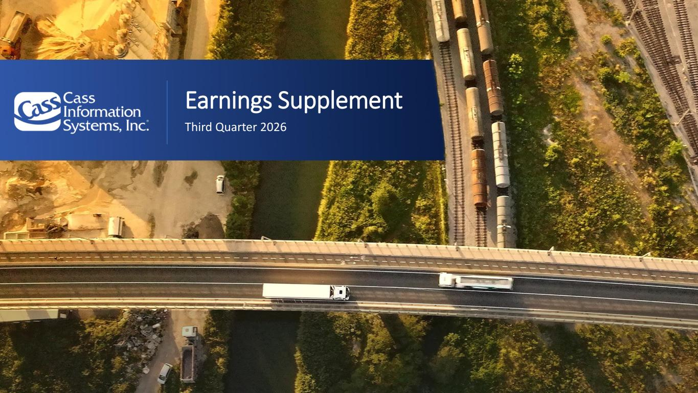

www.cassinfo.com | ©2026 Cass Information Systems | Earnings Supplement Third Quarter 2026

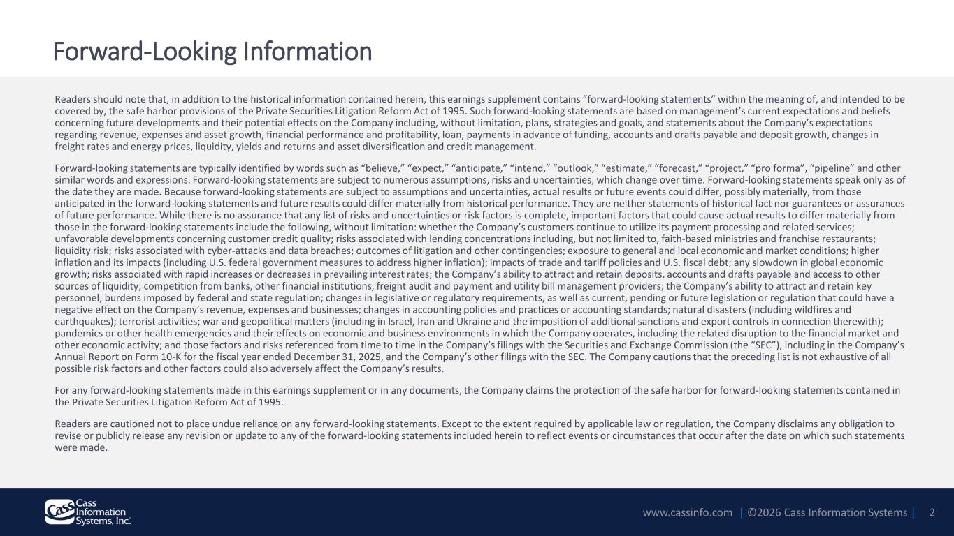
www.cassinfo.com | ©2026 Cass Information Systems | Forward-Looking Information Readers should note that, in addition to the historical information contained herein, this earnings supplement contains “forward-looking statements” within the meaning of, and intended to be covered by, the safe harbor provisions of the Private Securities Litigation Reform Act of 1995. Such forward-looking statements are based on management’s current expectations and beliefs concerning future developments and their potential effects on the Company including, without limitation, plans, strategies and goals, and statements about the Company’s expectations regarding revenue, expenses and asset growth, financial performance and profitability, loan, payments in advance of funding, accounts and drafts payable and deposit growth, changes in freight rates and energy prices, liquidity, yields and returns and asset diversification and credit management. Forward-looking statements are typically identified by words such as “believe,” “expect,” “anticipate,” “intend,” “outlook,” “estimate,” “forecast,” “project,” “pro forma”, “pipeline” and other similar words and expressions. Forward-looking statements are subject to numerous assumptions, risks and uncertainties, which change over time. Forward-looking statements speak only as of the date they are made. Because forward-looking statements are subject to assumptions and uncertainties, actual results or future events could differ, possibly materially, from those anticipated in the forward-looking statements and future results could differ materially from historical performance. They are neither statements of historical fact nor guarantees or assurances of future performance. While there is no assurance that any list of risks and uncertainties or risk factors is complete, important factors that could cause actual results to differ materially from those in the forward-looking statements include the following, without limitation: whether the Company’s customers continue to utilize its payment processing and related services; unfavorable developments concerning customer credit quality; risks associated with lending concentrations including, but not limited to, faith-based ministries and franchise restaurants; liquidity risk; risks associated with cyber-attacks and data breaches; outcomes of litigation and other contingencies; exposure to general and local economic and market conditions; higher inflation and its impacts (including U.S. federal government measures to address higher inflation); impacts of trade and tariff policies and U.S. fiscal debt; any slowdown in global economic growth; risks associated with rapid increases or decreases in prevailing interest rates; the Company’s ability to attract and retain deposits, accounts and drafts payable and access to other sources of liquidity; competition from banks, other financial institutions, freight audit and payment and utility bill management providers; the Company’s ability to attract and retain key personnel; burdens imposed by federal and state regulation; changes in legislative or regulatory requirements, as well as current, pending or future legislation or regulation that could have a negative effect on the Company’s revenue, expenses and businesses; changes in accounting policies and practices or accounting standards; natural disasters (including wildfires and earthquakes); terrorist activities; war and geopolitical matters (including in Israel, Iran and Ukraine and the imposition of additional sanctions and export controls in connection therewith); pandemics or other health emergencies and their effects on economic and business environments in which the Company operates, including the related disruption to the financial market and other economic activity; and those factors and risks referenced from time to time in the Company’s filings with the Securities and Exchange Commission (the “SEC”), including in the Company’s Annual Report on Form 10-K for the fiscal year ended December 31, 2025, and the Company’s other filings with the SEC. The Company cautions that the preceding list is not exhaustive of all possible risk factors and other factors could also adversely affect the Company’s results. For any forward-looking statements made in this earnings supplement or in any documents, the Company claims the protection of the safe harbor for forward-looking statements contained in the Private Securities Litigation Reform Act of 1995. Readers are cautioned not to place undue reliance on any forward-looking statements. Except to the extent required by applicable law or regulation, the Company disclaims any obligation to revise or publicly release any revision or update to any of the forward-looking statements included herein to reflect events or circumstances that occur after the date on which such statements were made. 2

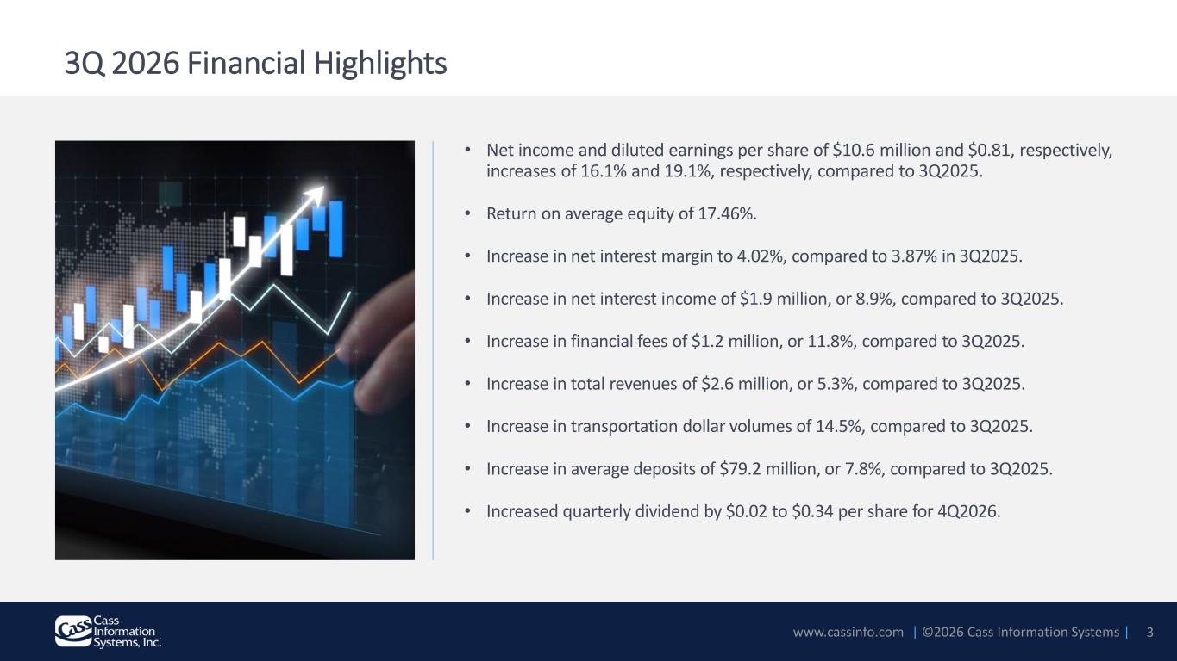
www.cassinfo.com | ©2026 Cass Information Systems | • Net income and diluted earnings per share of $10.6 million and $0.81, respectively, increases of 16.1% and 19.1%, respectively, compared to 3Q2025. • Return on average equity of 17.46%. • Increase in net interest margin to 4.02%, compared to 3.87% in 3Q2025. • Increase in net interest income of $1.9 million, or 8.9%, compared to 3Q2025. • Increase in financial fees of $1.2 million, or 11.8%, compared to 3Q2025. • Increase in total revenues of $2.6 million, or 5.3%, compared to 3Q2025. • Increase in transportation dollar volumes of 14.5%, compared to 3Q2025. • Increase in average deposits of $79.2 million, or 7.8%, compared to 3Q2025. • Increased quarterly dividend by $0.02 to $0.34 per share for 4Q2026. 3Q 2026 Financial Highlights 3

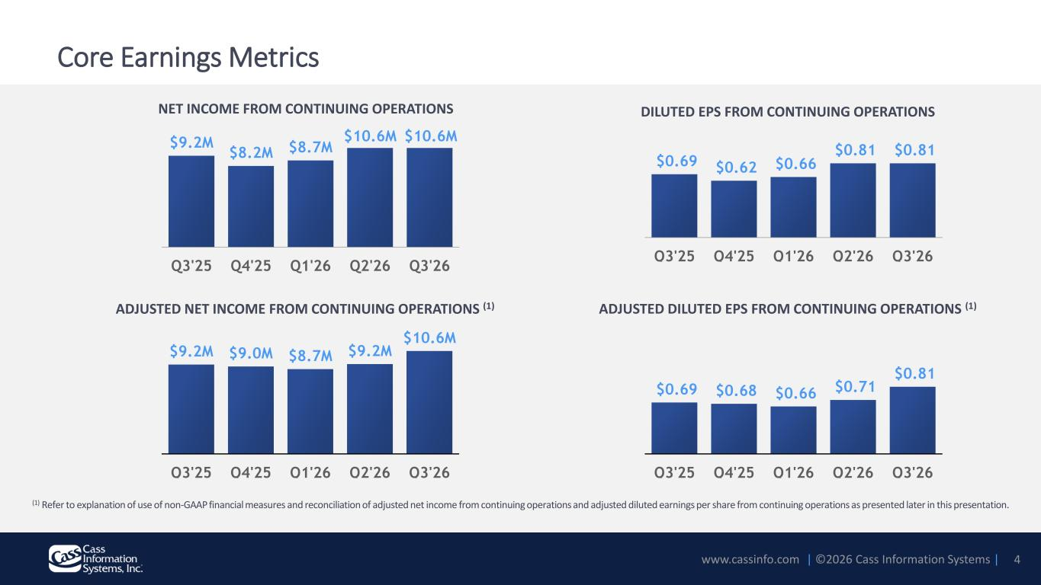
www.cassinfo.com | ©2026 Cass Information Systems | Core Earnings Metrics $9.2M $9.0M $8.7M $9.2M $10.6M Q3'25 Q4'25 Q1'26 Q2'26 Q3'26 $0.69 $0.68 $0.66 $0.71 $0.81 Q3'25 Q4'25 Q1'26 Q2'26 Q3'26 ADJUSTED NET INCOME FROM CONTINUING OPERATIONS (1) ADJUSTED DILUTED EPS FROM CONTINUING OPERATIONS (1) (1) Refer to explanation of use of non-GAAP financial measures and reconciliation of adjusted net income from continuing operations and adjusted diluted earnings per share from continuing operations as presented later in this presentation. $9.2M $8.2M $8.7M $10.6M $10.6M Q3'25 Q4'25 Q1'26 Q2'26 Q3'26 NET INCOME FROM CONTINUING OPERATIONS $0.69 $0.62 $0.66 $0.81 $0.81 Q3'25 Q4'25 Q1'26 Q2'26 Q3'26 DILUTED EPS FROM CONTINUING OPERATIONS 4

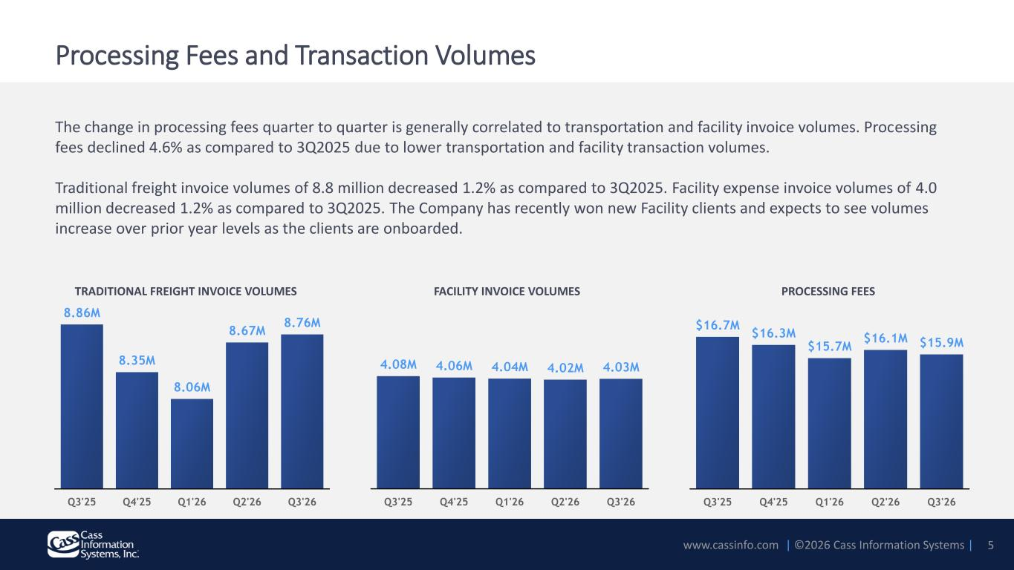
www.cassinfo.com | ©2026 Cass Information Systems | The change in processing fees quarter to quarter is generally correlated to transportation and facility invoice volumes. Processing fees declined 4.6% as compared to 3Q2025 due to lower transportation and facility transaction volumes. Traditional freight invoice volumes of 8.8 million decreased 1.2% as compared to 3Q2025. Facility expense invoice volumes of 4.0 million decreased 1.2% as compared to 3Q2025. The Company has recently won new Facility clients and expects to see volumes increase over prior year levels as the clients are onboarded. 8.86M 8.35M 8.06M 8.67M 8.76M Q3'25 Q4'25 Q1'26 Q2'26 Q3'26 4.08M 4.06M 4.04M 4.02M 4.03M Q3'25 Q4'25 Q1'26 Q2'26 Q3'26 $16.7M $16.3M $15.7M $16.1M $15.9M Q3'25 Q4'25 Q1'26 Q2'26 Q3'26 Processing Fees and Transaction Volumes TRADITIONAL FREIGHT INVOICE VOLUMES FACILITY INVOICE VOLUMES PROCESSING FEES 5

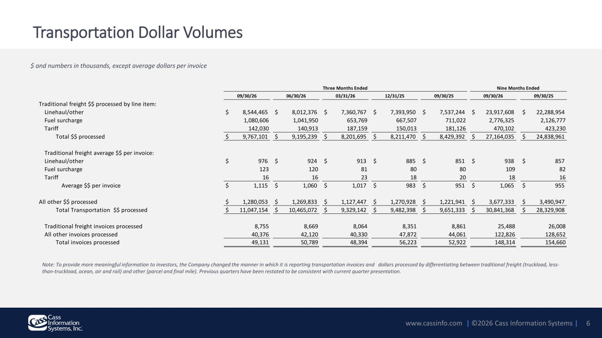
www.cassinfo.com | ©2026 Cass Information Systems | Transportation Dollar Volumes 6 $ and numbers in thousands, except average dollars per invoice 09/30/26 06/30/26 03/31/26 12/31/25 09/30/25 09/30/26 09/30/25 Traditional freight $$ processed by line item: Linehaul/other $ 8,544,465 $ 8,012,376 $ 7,360,767 $ 7,393,950 $ 7,537,244 $ 23,917,608 $ 22,288,954 Fuel surcharge 1,080,606 1,041,950 653,769 667,507 711,022 2,776,325 2,126,777 Tariff 142,030 140,913 187,159 150,013 181,126 470,102 423,230 Total $$ processed $ 9,767,101 $ 9,195,239 $ 8,201,695 $ 8,211,470 $ 8,429,392 $ 27,164,035 $ 24,838,961 Traditional freight average $$ per invoice: Linehaul/other $ 976 $ 924 $ 913 $ 885 $ 851 $ 938 $ 857 Fuel surcharge 123 120 81 80 80 109 82 Tariff 16 16 23 18 20 18 16 Average $$ per invoice $ 1,115 $ 1,060 $ 1,017 $ 983 $ 951 $ 1,065 $ 955 All other $$ processed $ 1,280,053 $ 1,269,833 $ 1,127,447 $ 1,270,928 $ 1,221,941 $ 3,677,333 $ 3,490,947 Total Transportation $$ processed $ 11,047,154 $ 10,465,072 $ 9,329,142 $ 9,482,398 $ 9,651,333 $ 30,841,368 $ 28,329,908 Traditional freight invoices processed 8,755 8,669 8,064 8,351 8,861 25,488 26,008 All other invoices processed 40,376 42,120 40,330 47,872 44,061 122,826 128,652 Total invoices processed 49,131 50,789 48,394 56,223 52,922 148,314 154,660 Three Months Ended Nine Months Ended Note: To provide more meaningful information to investors, the Company changed the manner in which it is reporting transportation invoices and dollars processed by differentiating between traditional freight (truckload, less- than-truckload, ocean, air and rail) and other (parcel and final mile). Previous quarters have been restated to be consistent with current quarter presentation.

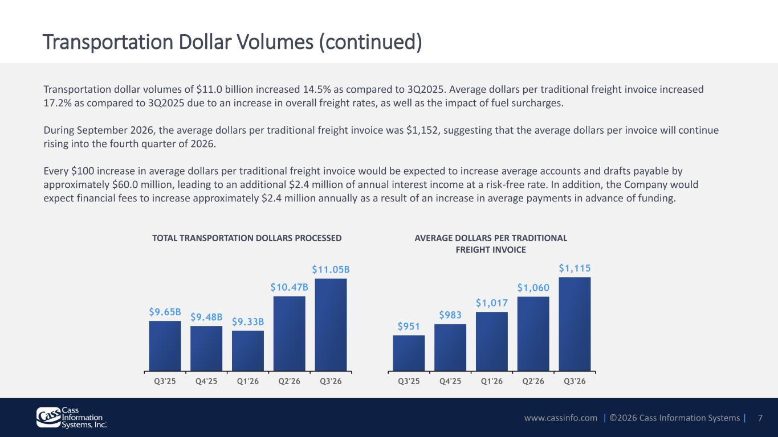
www.cassinfo.com | ©2026 Cass Information Systems | $9.65B $9.48B $9.33B $10.47B $11.05B 8E+09 8.5E+09 9E+09 9.5E+09 1E+10 1.05E+10 1.1E+10 1.15E+10 Q3'25 Q4'25 Q1'26 Q2'26 Q3'26 Transportation dollar volumes of $11.0 billion increased 14.5% as compared to 3Q2025. Average dollars per traditional freight invoice increased 17.2% as compared to 3Q2025 due to an increase in overall freight rates, as well as the impact of fuel surcharges. During September 2026, the average dollars per traditional freight invoice was $1,152, suggesting that the average dollars per invoice will continue rising into the fourth quarter of 2026. Every $100 increase in average dollars per traditional freight invoice would be expected to increase average accounts and drafts payable by approximately $60.0 million, leading to an additional $2.4 million of annual interest income at a risk-free rate. In addition, the Company would expect financial fees to increase approximately $2.4 million annually as a result of an increase in average payments in advance of funding. TOTAL TRANSPORTATION DOLLARS PROCESSED 7 AVERAGE DOLLARS PER TRADITIONAL FREIGHT INVOICE $951 $983 $1,017 $1,060 $1,115 850 900 950 1000 1050 1100 1150 Q3'25 Q4'25 Q1'26 Q2'26 Q3'26 Transportation Dollar Volumes (continued)

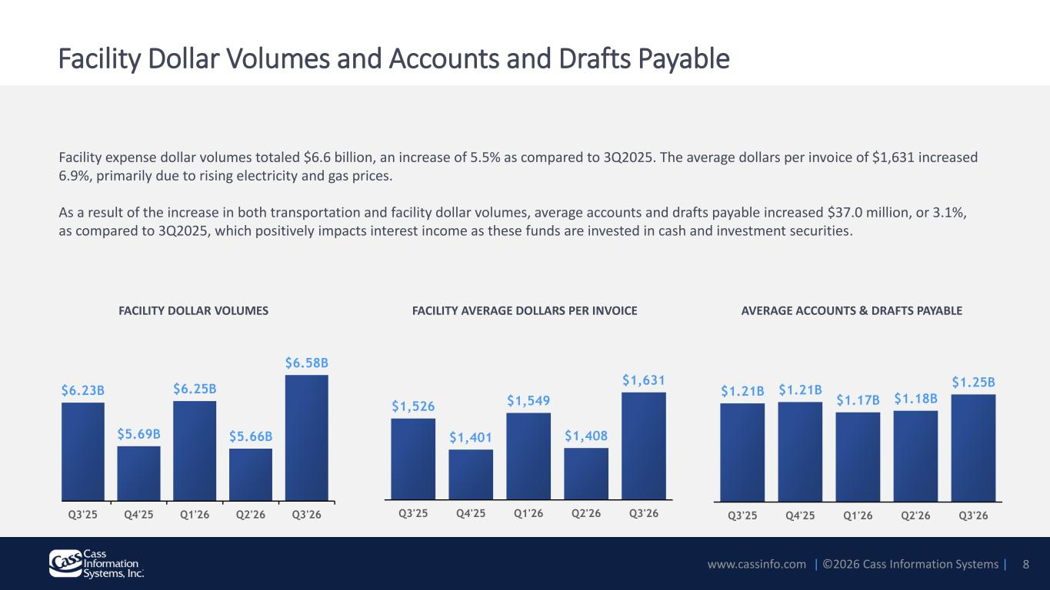
www.cassinfo.com | ©2026 Cass Information Systems | $1,526 $1,401 $1,549 $1,408 $1,631 Q3'25 Q4'25 Q1'26 Q2'26 Q3'26 $6.23B $5.69B $6.25B $5.66B $6.58B 5E+09 5.2E+09 5.4E+09 5.6E+09 5.8E+09 6E+09 6.2E+09 6.4E+09 6.6E+09 6.8E+09 Q3'25 Q4'25 Q1'26 Q2'26 Q3'26 $1.21B $1.21B $1.17B $1.18B $1.25B Q3'25 Q4'25 Q1'26 Q2'26 Q3'26 Facility expense dollar volumes totaled $6.6 billion, an increase of 5.5% as compared to 3Q2025. The average dollars per invoice of $1,631 increased 6.9%, primarily due to rising electricity and gas prices. As a result of the increase in both transportation and facility dollar volumes, average accounts and drafts payable increased $37.0 million, or 3.1%, as compared to 3Q2025, which positively impacts interest income as these funds are invested in cash and investment securities. Facility Dollar Volumes and Accounts and Drafts Payable FACILITY DOLLAR VOLUMES FACILITY AVERAGE DOLLARS PER INVOICE 8 AVERAGE ACCOUNTS & DRAFTS PAYABLE

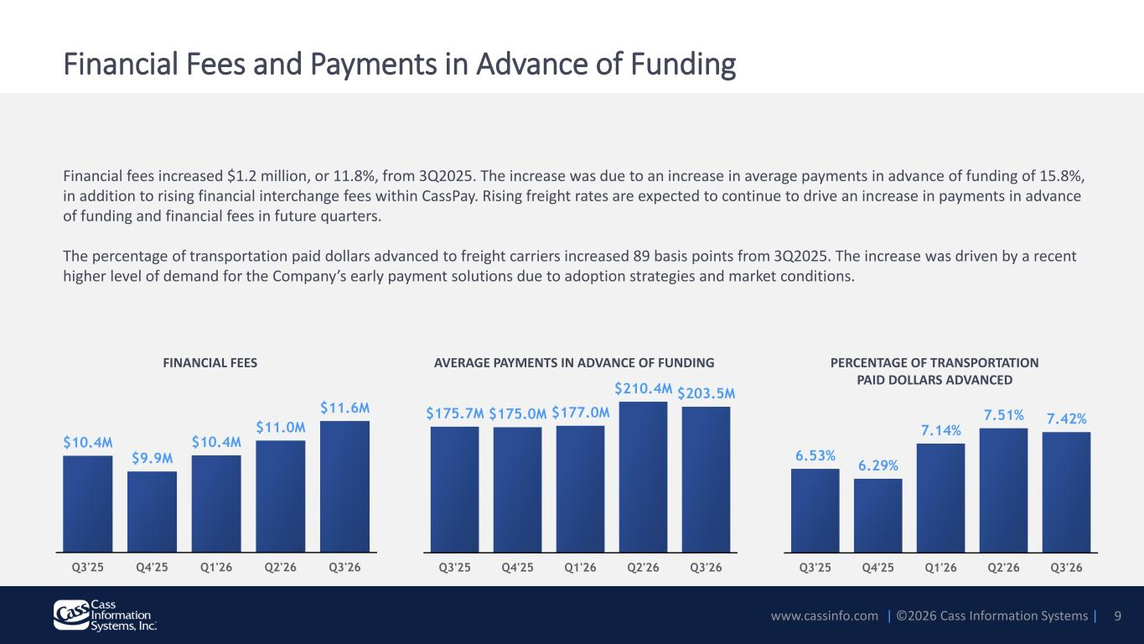
www.cassinfo.com | ©2026 Cass Information Systems | Financial Fees and Payments in Advance of Funding Financial fees increased $1.2 million, or 11.8%, from 3Q2025. The increase was due to an increase in average payments in advance of funding of 15.8%, in addition to rising financial interchange fees within CassPay. Rising freight rates are expected to continue to drive an increase in payments in advance of funding and financial fees in future quarters. The percentage of transportation paid dollars advanced to freight carriers increased 89 basis points from 3Q2025. The increase was driven by a recent higher level of demand for the Company’s early payment solutions due to adoption strategies and market conditions. $175.7M $175.0M $177.0M $210.4M $203.5M Q3'25 Q4'25 Q1'26 Q2'26 Q3'26 $10.4M $9.9M $10.4M $11.0M $11.6M Q3'25 Q4'25 Q1'26 Q2'26 Q3'26 AVERAGE PAYMENTS IN ADVANCE OF FUNDINGFINANCIAL FEES 9 6.53% 6.29% 7.14% 7.51% 7.42% Q3'25 Q4'25 Q1'26 Q2'26 Q3'26 PERCENTAGE OF TRANSPORTATION PAID DOLLARS ADVANCED

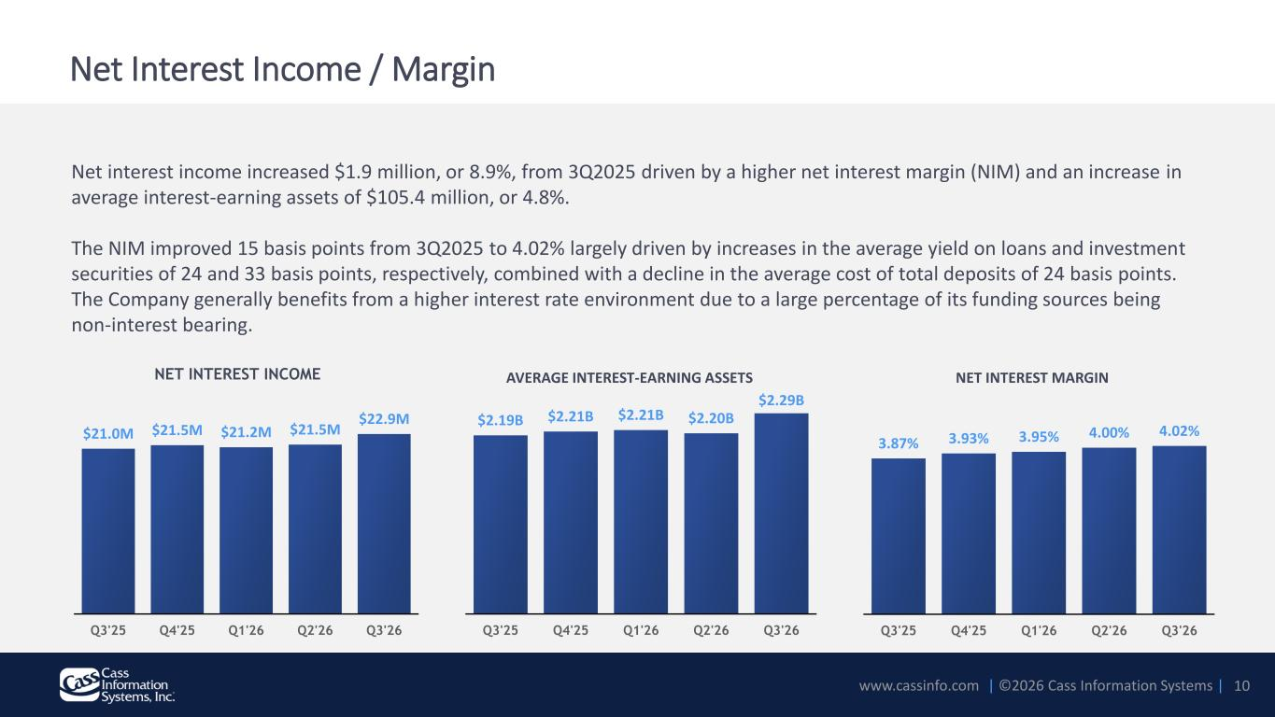
www.cassinfo.com | ©2026 Cass Information Systems | Net interest income increased $1.9 million, or 8.9%, from 3Q2025 driven by a higher net interest margin (NIM) and an increase in average interest-earning assets of $105.4 million, or 4.8%. The NIM improved 15 basis points from 3Q2025 to 4.02% largely driven by increases in the average yield on loans and investment securities of 24 and 33 basis points, respectively, combined with a decline in the average cost of total deposits of 24 basis points. The Company generally benefits from a higher interest rate environment due to a large percentage of its funding sources being non-interest bearing. Net Interest Income / Margin NET INTEREST INCOME $21.0M $21.5M $21.2M $21.5M $22.9M Q3'25 Q4'25 Q1'26 Q2'26 Q3'26 AVERAGE INTEREST-EARNING ASSETS $2.19B $2.21B $2.21B $2.20B $2.29B Q3'25 Q4'25 Q1'26 Q2'26 Q3'26 NET INTEREST MARGIN 3.87% 3.93% 3.95% 4.00% 4.02% Q3'25 Q4'25 Q1'26 Q2'26 Q3'26 10

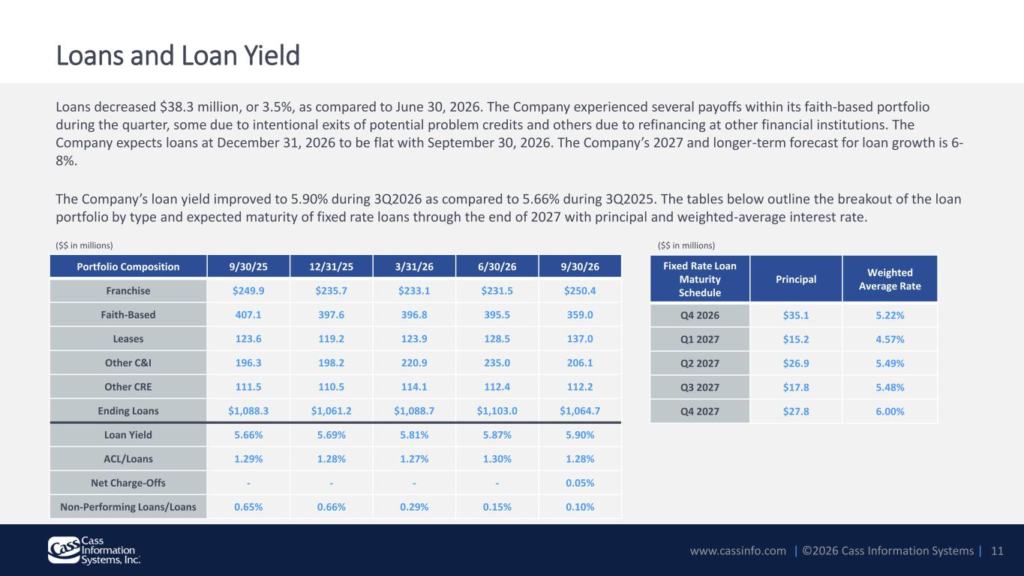
www.cassinfo.com | ©2026 Cass Information Systems | Loans decreased $38.3 million, or 3.5%, as compared to June 30, 2026. The Company experienced several payoffs within its faith-based portfolio during the quarter, some due to intentional exits of potential problem credits and others due to refinancing at other financial institutions. The Company expects loans at December 31, 2026 to be flat with September 30, 2026. The Company’s 2027 and longer-term forecast for loan growth is 6- 8%. The Company’s loan yield improved to 5.90% during 3Q2026 as compared to 5.66% during 3Q2025. The tables below outline the breakout of the loan portfolio by type and expected maturity of fixed rate loans through the end of 2027 with principal and weighted-average interest rate. 11 Portfolio Composition 9/30/25 12/31/25 3/31/26 6/30/26 9/30/26 Franchise $249.9 $235.7 $233.1 $231.5 $250.4 Faith-Based 407.1 397.6 396.8 395.5 359.0 Leases 123.6 119.2 123.9 128.5 137.0 Other C&I 196.3 198.2 220.9 235.0 206.1 Other CRE 111.5 110.5 114.1 112.4 112.2 Ending Loans $1,088.3 $1,061.2 $1,088.7 $1,103.0 $1,064.7 Loan Yield 5.66% 5.69% 5.81% 5.87% 5.90% ACL/Loans 1.29% 1.28% 1.27% 1.30% 1.28% Net Charge-Offs - - - - 0.05% Non-Performing Loans/Loans 0.65% 0.66% 0.29% 0.15% 0.10% ($$ in millions) Fixed Rate Loan Maturity Schedule Principal Weighted Average Rate Q4 2026 $35.1 5.22% Q1 2027 $15.2 4.57% Q2 2027 $26.9 5.49% Q3 2027 $17.8 5.48% Q4 2027 $27.8 6.00% ($$ in millions) Loans and Loan Yield

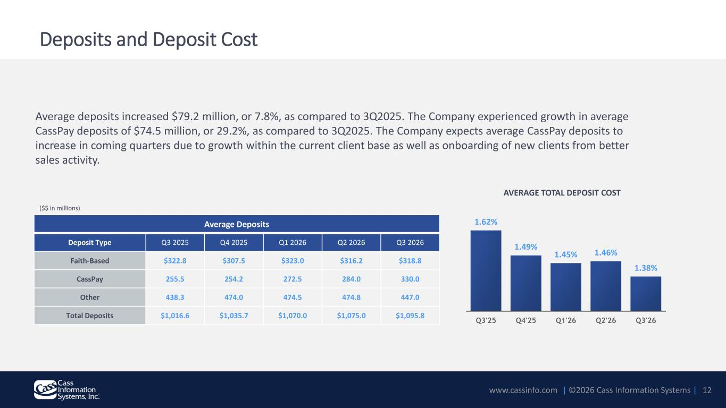
www.cassinfo.com | ©2026 Cass Information Systems | Average deposits increased $79.2 million, or 7.8%, as compared to 3Q2025. The Company experienced growth in average CassPay deposits of $74.5 million, or 29.2%, as compared to 3Q2025. The Company expects average CassPay deposits to increase in coming quarters due to growth within the current client base as well as onboarding of new clients from better sales activity. Deposits and Deposit Cost 12 AVERAGE TOTAL DEPOSIT COST 1.62% 1.49% 1.45% 1.46% 1.38% Q3'25 Q4'25 Q1'26 Q2'26 Q3'26 Average Deposits Deposit Type Q3 2025 Q4 2025 Q1 2026 Q2 2026 Q3 2026 Faith-Based $322.8 $307.5 $323.0 $316.2 $318.8 CassPay 255.5 254.2 272.5 284.0 330.0 Other 438.3 474.0 474.5 474.8 447.0 Total Deposits $1,016.6 $1,035.7 $1,070.0 $1,075.0 $1,095.8 ($$ in millions)

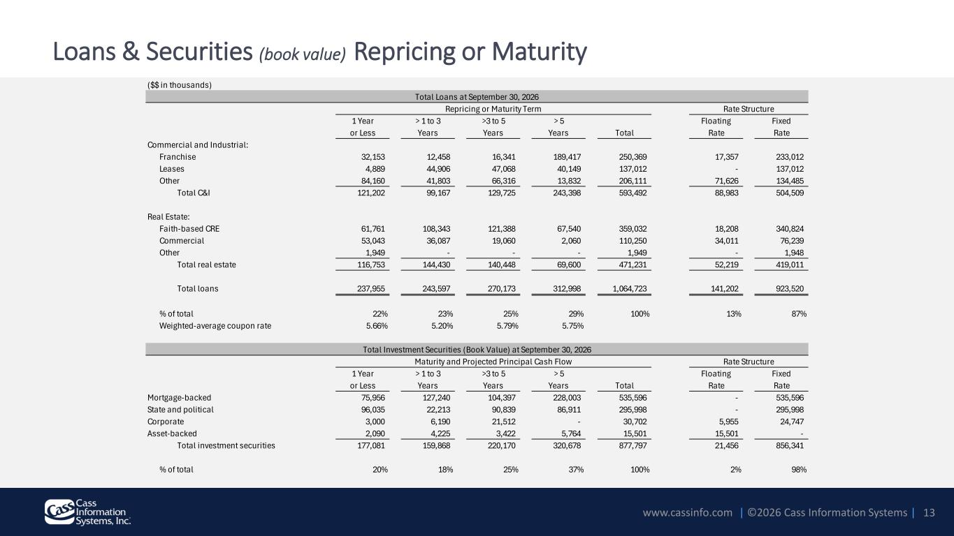
www.cassinfo.com | ©2026 Cass Information Systems | Loans & Securities (book value) Repricing or Maturity 13 ($$ in thousands) 1 Year > 1 to 3 >3 to 5 > 5 Floating Fixed or Less Years Years Years Total Rate Rate Commercial and Industrial: Franchise 32,153 12,458 16,341 189,417 250,369 17,357 233,012 Leases 4,889 44,906 47,068 40,149 137,012 - 137,012 Other 84,160 41,803 66,316 13,832 206,111 71,626 134,485 Total C&I 121,202 99,167 129,725 243,398 593,492 88,983 504,509 Real Estate: Faith-based CRE 61,761 108,343 121,388 67,540 359,032 18,208 340,824 Commercial 53,043 36,087 19,060 2,060 110,250 34,011 76,239 Other 1,949 - - - 1,949 - 1,948 Total real estate 116,753 144,430 140,448 69,600 471,231 52,219 419,011 Total loans 237,955 243,597 270,173 312,998 1,064,723 141,202 923,520 % of total 22% 23% 25% 29% 100% 13% 87% Weighted-average coupon rate 5.66% 5.20% 5.79% 5.75% 1 Year > 1 to 3 >3 to 5 > 5 Floating Fixed or Less Years Years Years Total Rate Rate Mortgage-backed 75,956 127,240 104,397 228,003 535,596 - 535,596 State and political 96,035 22,213 90,839 86,911 295,998 - 295,998 Corporate 3,000 6,190 21,512 - 30,702 5,955 24,747 Asset-backed 2,090 4,225 3,422 5,764 15,501 15,501 - Total investment securities 177,081 159,868 220,170 320,678 877,797 21,456 856,341 % of total 20% 18% 25% 37% 100% 2% 98% Total Loans at September 30, 2026 Repricing or Maturity Term Rate Structure Total Investment Securities (Book Value) at September 30, 2026 Maturity and Projected Principal Cash Flow Rate Structure

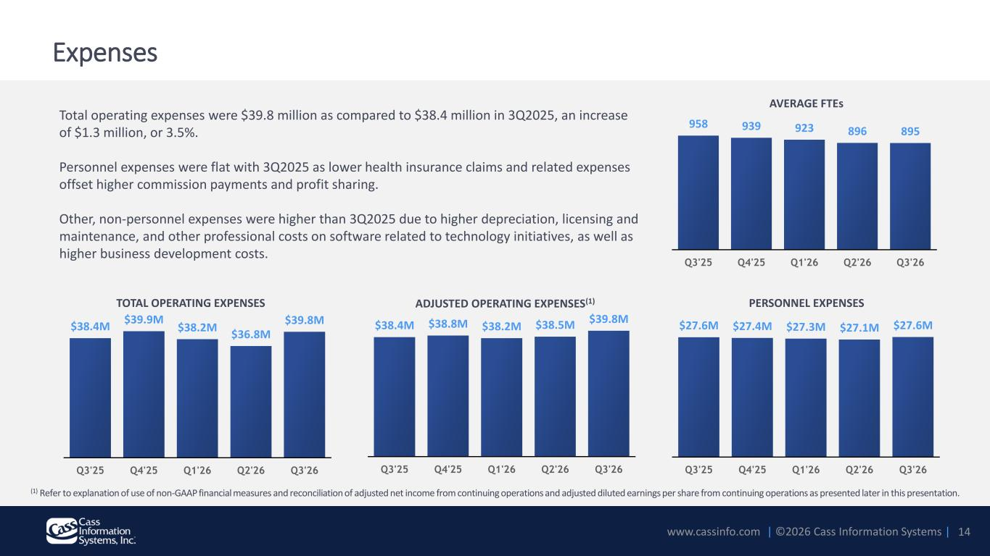
www.cassinfo.com | ©2026 Cass Information Systems | $27.6M $27.4M $27.3M $27.1M $27.6M Q3'25 Q4'25 Q1'26 Q2'26 Q3'26 $38.4M $39.9M $38.2M $36.8M $39.8M Q3'25 Q4'25 Q1'26 Q2'26 Q3'26 $38.4M $38.8M $38.2M $38.5M $39.8M Q3'25 Q4'25 Q1'26 Q2'26 Q3'26 Total operating expenses were $39.8 million as compared to $38.4 million in 3Q2025, an increase of $1.3 million, or 3.5%. Personnel expenses were flat with 3Q2025 as lower health insurance claims and related expenses offset higher commission payments and profit sharing. Other, non-personnel expenses were higher than 3Q2025 due to higher depreciation, licensing and maintenance, and other professional costs on software related to technology initiatives, as well as higher business development costs. Expenses PERSONNEL EXPENSES 14 ADJUSTED OPERATING EXPENSES(1)TOTAL OPERATING EXPENSES (1) Refer to explanation of use of non-GAAP financial measures and reconciliation of adjusted net income from continuing operations and adjusted diluted earnings per share from continuing operations as presented later in this presentation. AVERAGE FTEs 958 939 923 896 895 Q3'25 Q4'25 Q1'26 Q2'26 Q3'26

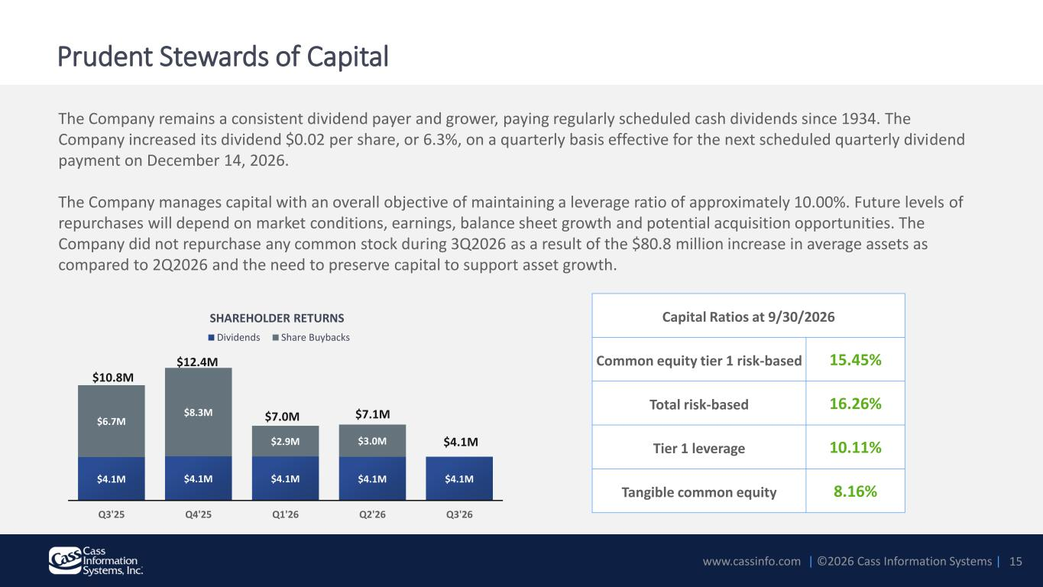
www.cassinfo.com | ©2026 Cass Information Systems | The Company remains a consistent dividend payer and grower, paying regularly scheduled cash dividends since 1934. The Company increased its dividend $0.02 per share, or 6.3%, on a quarterly basis effective for the next scheduled quarterly dividend payment on December 14, 2026. The Company manages capital with an overall objective of maintaining a leverage ratio of approximately 10.00%. Future levels of repurchases will depend on market conditions, earnings, balance sheet growth and potential acquisition opportunities. The Company did not repurchase any common stock during 3Q2026 as a result of the $80.8 million increase in average assets as compared to 2Q2026 and the need to preserve capital to support asset growth. Prudent Stewards of Capital 15 Capital Ratios at 9/30/2026 Common equity tier 1 risk-based 15.45% Total risk-based 16.26% Tier 1 leverage 10.11% Tangible common equity 8.16% SHAREHOLDER RETURNS $4.1M $4.1M $4.1M $4.1M $4.1M $6.7M $8.3M $2.9M $3.0M Q3'25 Q4'25 Q1'26 Q2'26 Q3'26 Dividends Share Buybacks $7.0M $12.4M $10.8M $4.1M $7.1M

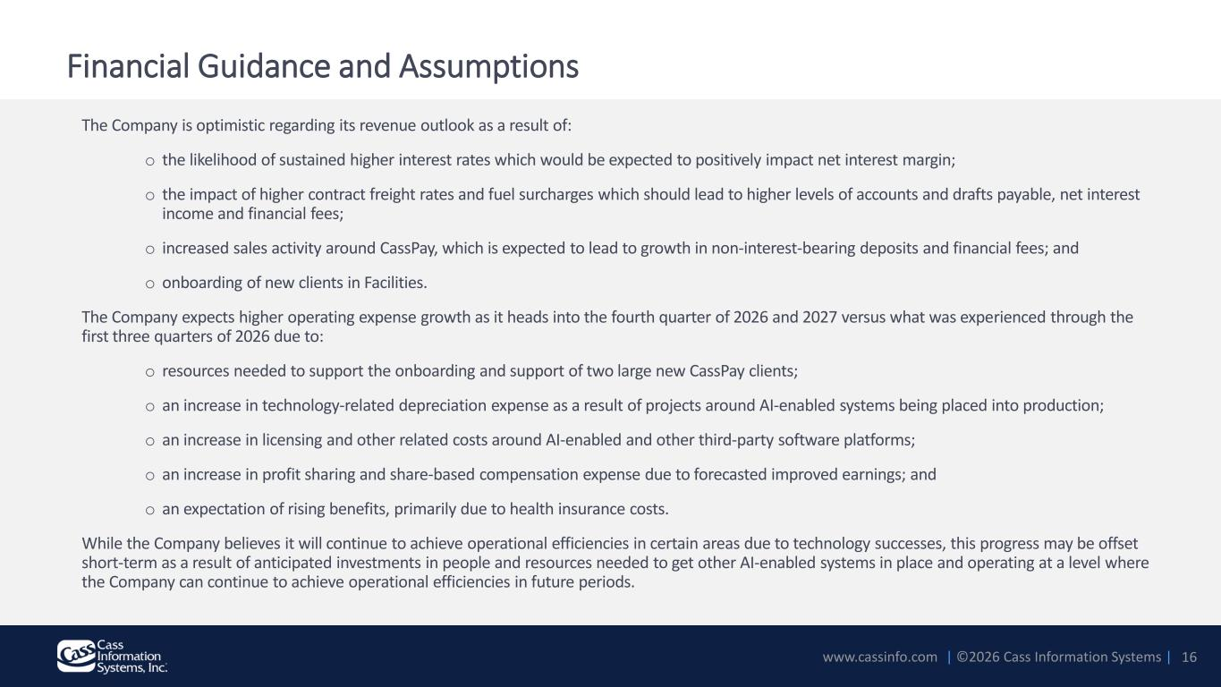
www.cassinfo.com | ©2026 Cass Information Systems | The Company is optimistic regarding its revenue outlook as a result of: o the likelihood of sustained higher interest rates which would be expected to positively impact net interest margin; o the impact of higher contract freight rates and fuel surcharges which should lead to higher levels of accounts and drafts payable, net interest income and financial fees; o increased sales activity around CassPay, which is expected to lead to growth in non-interest-bearing deposits and financial fees; and o onboarding of new clients in Facilities. The Company expects higher operating expense growth as it heads into the fourth quarter of 2026 and 2027 versus what was experienced through the first three quarters of 2026 due to: o resources needed to support the onboarding and support of two large new CassPay clients; o an increase in technology-related depreciation expense as a result of projects around AI-enabled systems being placed into production; o an increase in licensing and other related costs around AI-enabled and other third-party software platforms; o an increase in profit sharing and share-based compensation expense due to forecasted improved earnings; and o an expectation of rising benefits, primarily due to health insurance costs. While the Company believes it will continue to achieve operational efficiencies in certain areas due to technology successes, this progress may be offset short-term as a result of anticipated investments in people and resources needed to get other AI-enabled systems in place and operating at a level where the Company can continue to achieve operational efficiencies in future periods. 16 Financial Guidance and Assumptions

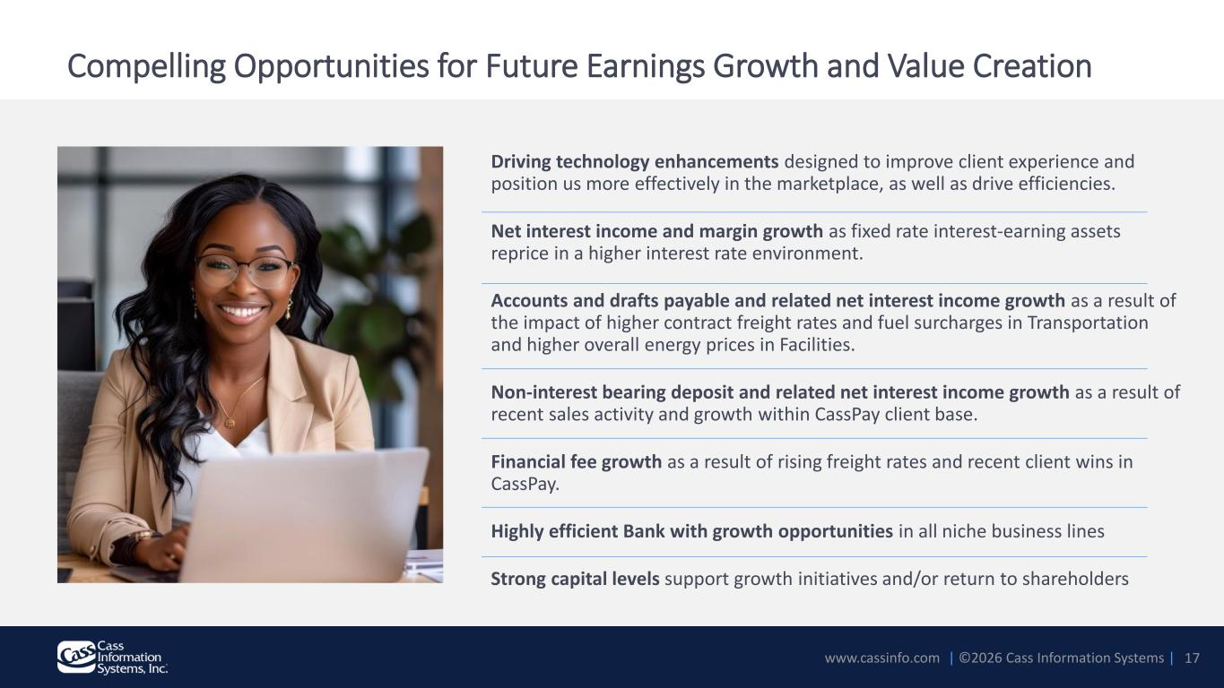
www.cassinfo.com | ©2026 Cass Information Systems | Compelling Opportunities for Future Earnings Growth and Value Creation Driving technology enhancements designed to improve client experience and position us more effectively in the marketplace, as well as drive efficiencies. Net interest income and margin growth as fixed rate interest-earning assets reprice in a higher interest rate environment. Accounts and drafts payable and related net interest income growth as a result of the impact of higher contract freight rates and fuel surcharges in Transportation and higher overall energy prices in Facilities. Non-interest bearing deposit and related net interest income growth as a result of recent sales activity and growth within CassPay client base. Financial fee growth as a result of rising freight rates and recent client wins in CassPay. Highly efficient Bank with growth opportunities in all niche business lines Strong capital levels support growth initiatives and/or return to shareholders 17


www.cassinfo.com | ©2026 Cass Information Systems | Appendix 18

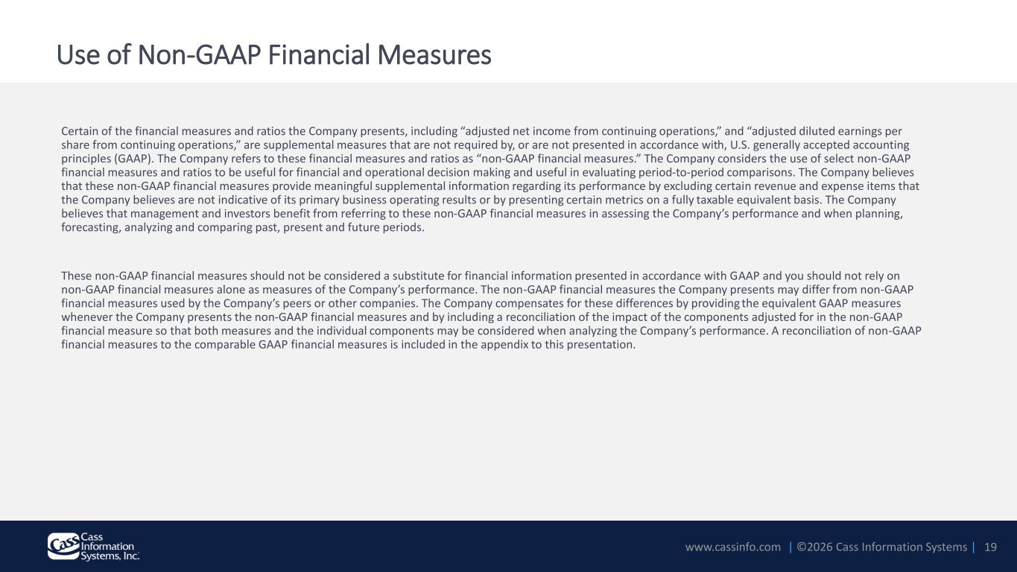
www.cassinfo.com | ©2026 Cass Information Systems | Use of Non-GAAP Financial Measures Certain of the financial measures and ratios the Company presents, including “adjusted net income from continuing operations,” and “adjusted diluted earnings per share from continuing operations,” are supplemental measures that are not required by, or are not presented in accordance with, U.S. generally accepted accounting principles (GAAP). The Company refers to these financial measures and ratios as “non-GAAP financial measures.” The Company considers the use of select non-GAAP financial measures and ratios to be useful for financial and operational decision making and useful in evaluating period-to-period comparisons. The Company believes that these non-GAAP financial measures provide meaningful supplemental information regarding its performance by excluding certain revenue and expense items that the Company believes are not indicative of its primary business operating results or by presenting certain metrics on a fully taxable equivalent basis. The Company believes that management and investors benefit from referring to these non-GAAP financial measures in assessing the Company’s performance and when planning, forecasting, analyzing and comparing past, present and future periods. These non-GAAP financial measures should not be considered a substitute for financial information presented in accordance with GAAP and you should not rely on non-GAAP financial measures alone as measures of the Company’s performance. The non-GAAP financial measures the Company presents may differ from non-GAAP financial measures used by the Company’s peers or other companies. The Company compensates for these differences by providing the equivalent GAAP measures whenever the Company presents the non-GAAP financial measures and by including a reconciliation of the impact of the components adjusted for in the non-GAAP financial measure so that both measures and the individual components may be considered when analyzing the Company’s performance. A reconciliation of non-GAAP financial measures to the comparable GAAP financial measures is included in the appendix to this presentation. 19

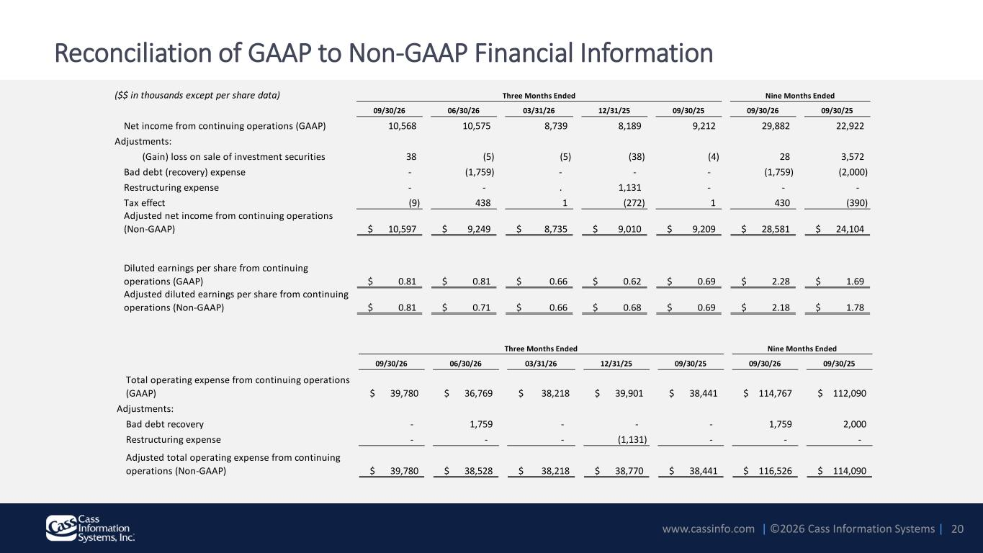
www.cassinfo.com | ©2026 Cass Information Systems | Reconciliation of GAAP to Non-GAAP Financial Information 20 09/30/26 06/30/26 03/31/26 12/31/25 09/30/25 09/30/26 09/30/25 Total operating expense from continuing operations (GAAP) $ 39,780 $ 36,769 $ 38,218 $ 39,901 $ 38,441 $ 114,767 $ 112,090 Adjustments: Bad debt recovery - 1,759 - - - 1,759 2,000 Restructuring expense - - - (1,131) - - - Adjusted total operating expense from continuing operations (Non-GAAP) $ 39,780 $ 38,528 $ 38,218 $ 38,770 $ 38,441 $ 116,526 $ 114,090 Three Months Ended Nine Months Ended ($$ in thousands except per share data) 09/30/26 06/30/26 03/31/26 12/31/25 09/30/25 09/30/26 09/30/25 Net income from continuing operations (GAAP) 10,568 10,575 8,739 8,189 9,212 29,882 22,922 Adjustments: (Gain) loss on sale of investment securities 38 (5) (5) (38) (4) 28 3,572 Bad debt (recovery) expense - (1,759) - - - (1,759) (2,000) Restructuring expense - - . 1,131 - - - Tax effect (9) 438 1 (272) 1 430 (390) Adjusted net income from continuing operations (Non-GAAP) $ 10,597 $ 9,249 $ 8,735 $ 9,010 $ 9,209 $ 28,581 $ 24,104 Diluted earnings per share from continuing operations (GAAP) $ 0.81 $ 0.81 $ 0.66 $ 0.62 $ 0.69 $ 2.28 $ 1.69 Adjusted diluted earnings per share from continuing operations (Non-GAAP) $ 0.81 $ 0.71 $ 0.66 $ 0.68 $ 0.69 $ 2.18 $ 1.78 Three Months Ended Nine Months Ended

